Swinburne University of Technology

ICT10001 - Problem Solving with ICT  
Semester: September 2021

User Guide

Baby Hut by G27

Ict15.swin.edu.vn

|  |  |  |
| --- | --- | --- |
| Nguyen Thanh Dat | | 103804881 |
| Nguyen Thanh Long | | 103805143 |
| Ton Tri Trung  Tran Tuan Nam | | 103808977  103792643 |
|  |

**Class**: ICT10001.2

**Lecturer**: Dr. Duc Minh Le

**Tutor:** Ms. Thuy Linh Nguyen

*(this page is intentionally left blank)*

Table of Contents

1. Overview 1

2. Administrative information 1

2.1 WordPress - Use for managing most features of the website. 1

2.2 NitroPack - Use for optimizing website speed 2

2.3 Google Analytics - Use for website analytics 3

2.4 Metorik - Use for sales analysis 3

2.5 Tidio - Use for live-chatting with visitors 4

3. To access the website 4

3.1 View the website 4

3.2 Login as an administrator. 5

4. About the website pages 5

4.1 To add a new page 5

4.2 To view a new page 9

4.3 Update a web page 9

4.4 Delete a page 10

5. Blog posting 11

5.1 Adding new post 11

5.2 Editing a post 12

5.3 Deleting a post 13

6. Communication with customers 14

6.1 Contact Form 14

6.1.1 Add contact us form for customers 14

6.1.2 Edit contact us form 19

6.2 Live-chat 21

7. Social media with the website 22

8. Products management 22

8.1 Adding new products 22

8.2 Adding information to your newly added products 25

8.3 Creating Variable Products and Attributes 27

8.4 Product Short Description guide 30

8.5 Managing WooCommerce Products 31

9. Using website analytics 32

9.1 Overview 32

9.2 Viewing traffic number 33

10. Generating Back-ups 36

10.1 Why should I Backup ? 36

10.2 How often should I Backup ? 36

10.3 Where should I store the backups? 37

10.4 How can I back-up my website? 37

10.5 How can I restore my website? 38

11. Reports generation 39

11.1 Overview 39

11.2 Metorik plugin 39

11.2.1 Login 39

11.2.2 Member list report 40

11.2.3 Sale analysis report 43

11.3 WordPress plugins 45

11.3.1 Login 45

11.3.2 Rental reports 46

11.3.3 Member transaction history 47

11.3.4 Rental Analysis Report 49

11.3.5 Catalogue of Baby Equipment 51

11.3.5 Out of stock report 53

11.3.6 Return report 54

12. Optimizing page speed 56

12.1 Login 57

12.2 Changing optimization settings 58

13. Technical summary 58

13.1 Domain information 58

13.2 Hosting information 59

13.3 WordPress site 60

13.4 Google account for Google Analytics 60

Appendices 60

# 1. Overview

http://ict15.swin.edu.vn is the website of the Baby Hut company.

The site provides the following back-end functions for the business:

1. Providing a method to easily add and edit web pages.
2. Providing a blog for posting baby-related guides.
3. Providing 2 methods for customers to communicate with Baby Hut.
4. Integrated social media links that connect to Baby Hut’s social media pages.
5. Providing a product management system.
6. Back-up service for the whole website.
7. Generating reports on sales, member lists, etc. for Baby Hut.
8. Optimizing web speed service for Baby Hut

# 2. Administrative information

Besides WordPress, our site uses several other sites to manage the website's functionalities. This section will provide account information to login to each site. **Caution: DO NOT PUBLIC THESE INFORMATION OR ELSE OUR SITE WILL FACE GREAT DANGER!**

## 2.1 WordPress - Use for managing most features of the website.

Username: user

Password: 4KMO9IvmNfy0

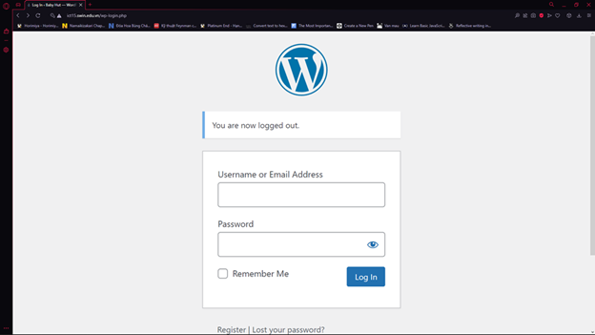

## 2.2 NitroPack - Use for optimizing website speed

Username: datntswh00741@fpt.edu.vn

Password: Void1502

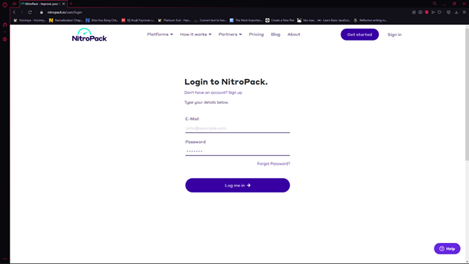

## 2.3 Google Analytics - Use for website analytics

Username: [datntswh00741@fpt.edu.vn](mailto:datntswh00741@fpt.edu.vn)

Password: Void1502

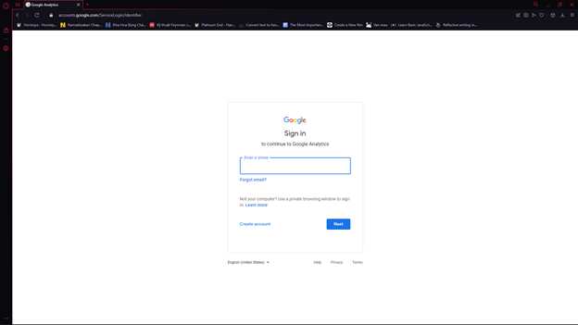

## 2.4 Metorik - Use for sales analysis

Username: datntswh00741@fpt.edu.vn

Password: Void1502

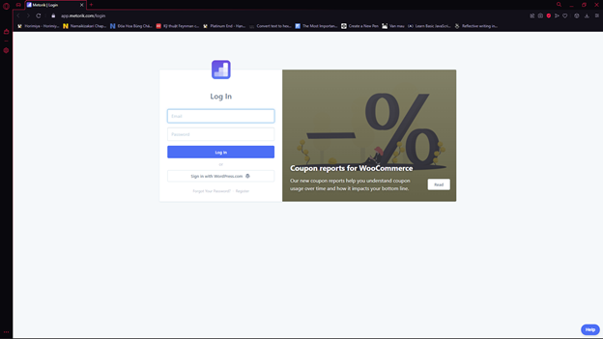

## 2.5 Tidio - Use for live-chatting with visitors

User: [datntswh00741@fpt.edu.vn](mailto:datntswh00741@fpt.edu.vn)

Password: Babyhut1234

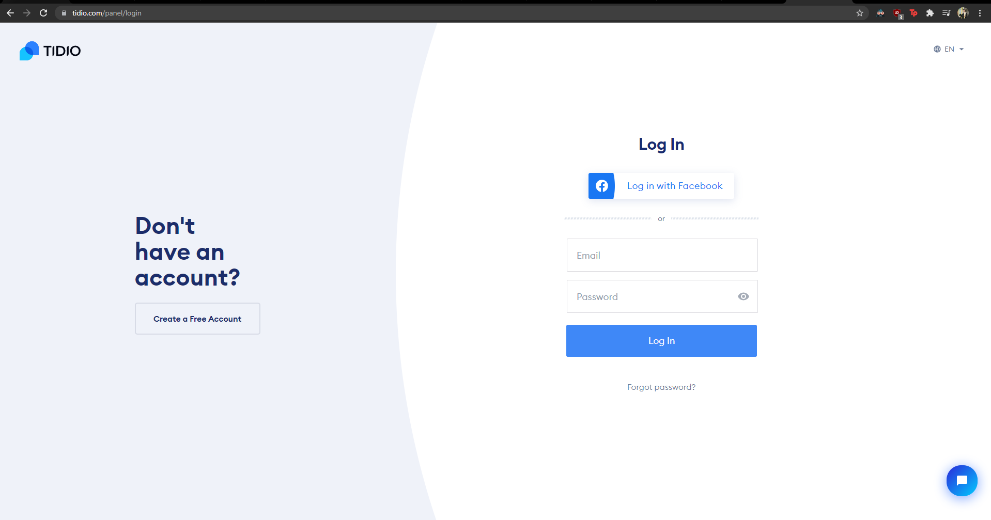

# 3. To access the website

## 3.1 View the website

Please open your browser and enter the following URL to the navigation bar: **http://ict15.swin.edu.vn.** This will lead you to the site.

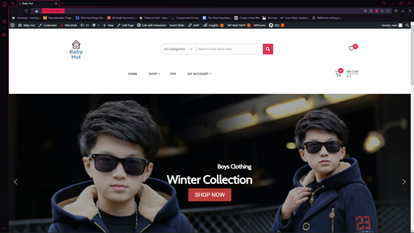

## 3.2 Login as an administrator.

**Step 1**: enter the following to the navigation bar: http://ict15.swin.edu.vn/wp-admin

**Step 2:** fill in the log-in dialog below with the username and password provided in **section 2. Administrative information**, then click on the **login** button.

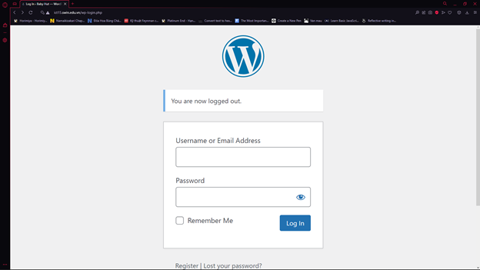

# 4. About the website pages

## 4.1 To add a new page

When you have logged in successfully, you will see the dashboard of Wordpress. On the left side of the dashboard is the menu for you to make adjustments to the web site.

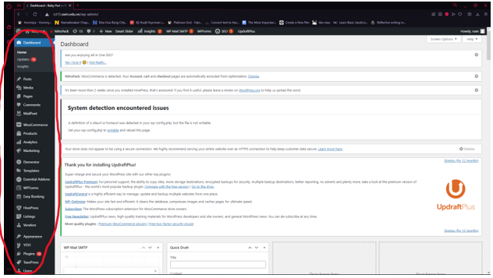

In the menu, you can see the “pages” link, click on it. There is a button named “Add new” at the top left of the page, click this button to create a new page for the website.

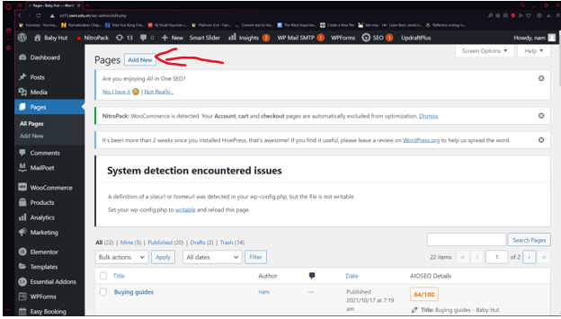

To write the title of the page, simply click on the **Add title** box and enter the desired title.

To add the content of the page, click on the big white box to start your writing. The editing tool above it will assist you with the process.

To save your work for later, click the **Save draft** button.

To see how your new page looks, click the **Preview** button.

To officially add the page to the website, click on the **Publish** button.

or you can use **Edit with Elementor** to design your page. For further understanding of how to use Elementor, please refer to Appendix #1: Guide on using Elementor.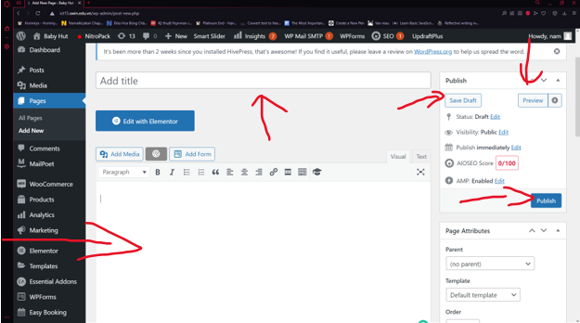

After publishing a page, you should know where to put your page in the appropriate menu. You can use the quick edit function. Just hover to the name of the page and click the **quick edit** link right under it as this screenshot has illustrated.

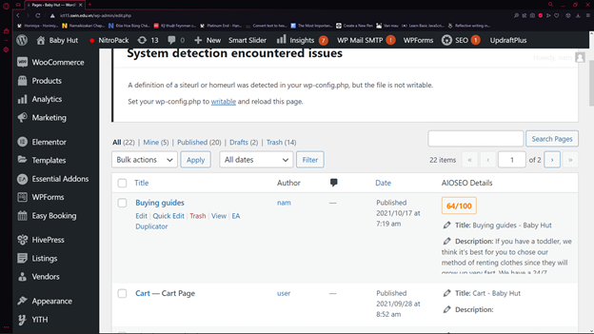

You can easily choose the parent for the page, the template for the page, and many other features.

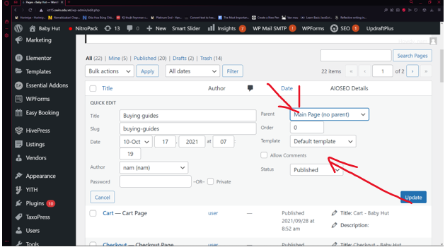

## 4.2 To view a new page

When hovering over the name of the page, below it there is a “view” link, you can click on it to see the page.

You can also view the page by going through the menu of the website to where the page is located or using the page URL and pasting it on the navigation bar.

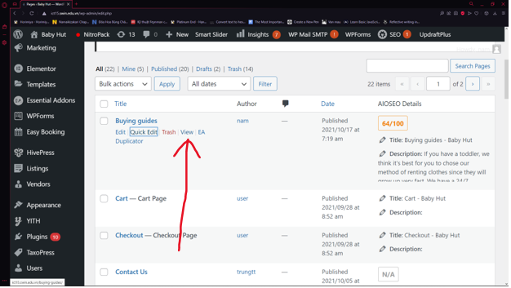

## 4.3 Update a web page

Using the same method mentioned in 5.1 and 5.2, we can click on the “edit” link to make adjustments to the web page.

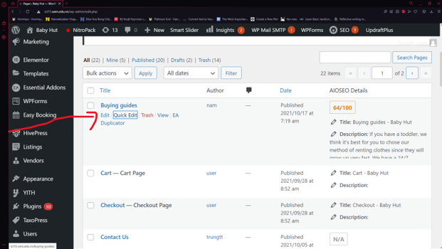

## 4.4 Delete a page

Next to the “quick edit” links mentioned earlier, the “trash” link can be used to delete that web page.

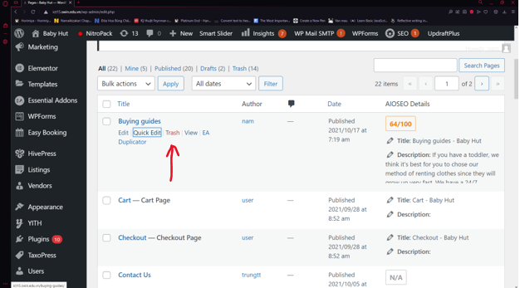

# 5. Blog posting

## 5.1 Adding new post

**Step 1:** On the left-side, find and hover on **Post.** Then, click **Add new.**

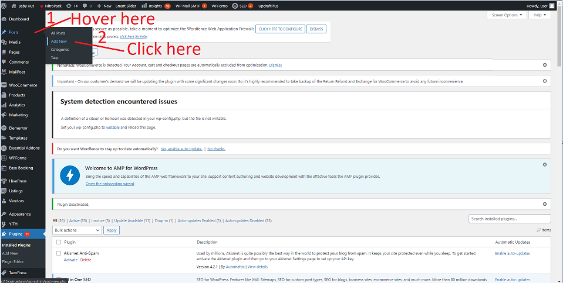

**Step 2:** Just like adding a new page, you can either fill in information such as **Title, description, save as draft, preview, publish** or you can use **Edit with Elementor** to design your post. For further understanding of how to use Elementor, please refer to this please refer to Appendix #1: Guide on using Elementor. 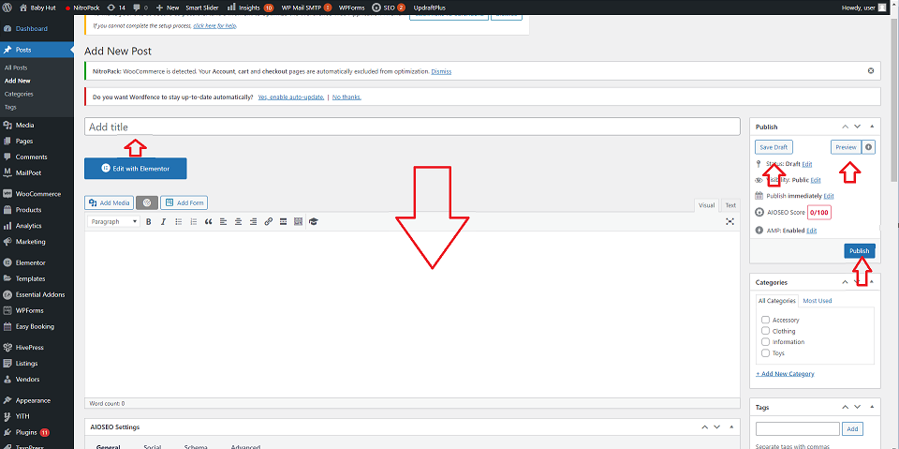

## 5.2 Editing a post

**Step 1:** Under the **Posts** section, click **All posts**.

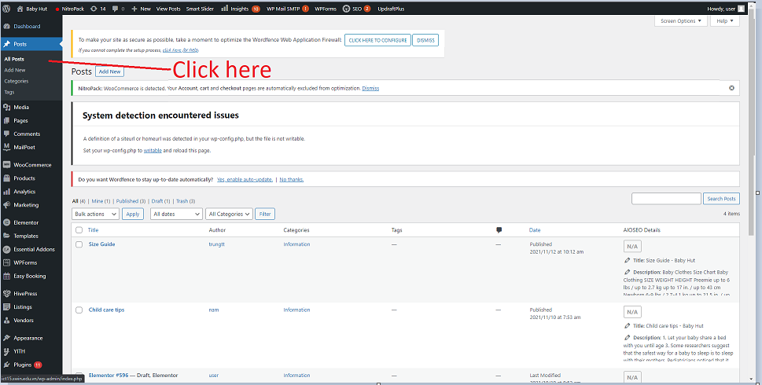

**Step 2:** Then, hover to any post you would like to edit, then you can either **Edit** or **Quick edit. Quick edit** will allow you to quickly edit elements such as **title, slug, date, author, categories, template, tags, status.** 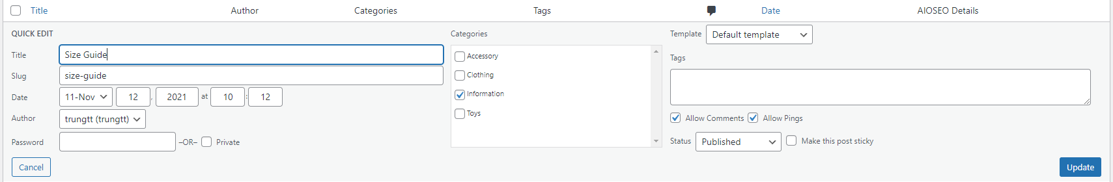

As for **Edit,** you will go through the step 2 in 6.1, where you can further edit the details of the post.

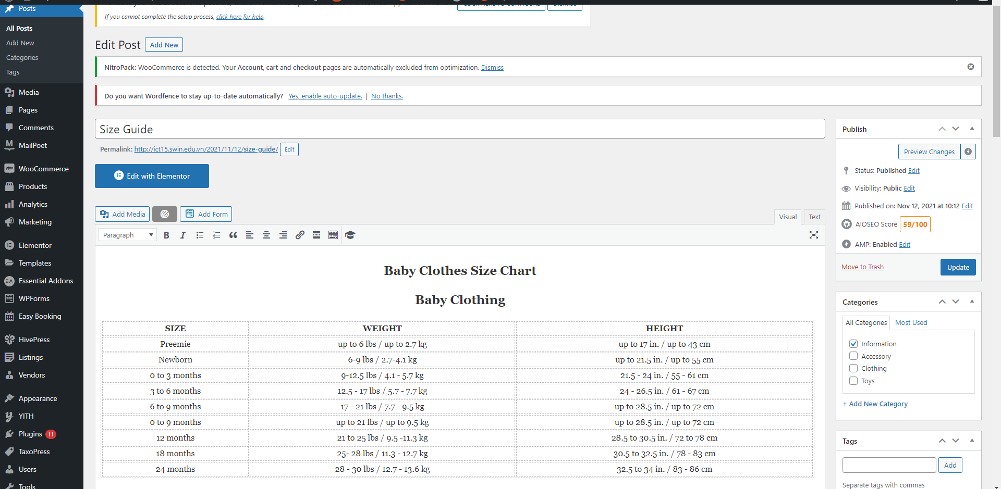

## 5.3 Deleting a post

**Step 1:** Under the **Posts** section, click **All posts**.



**Step 2:** Hover to any post you would like to delete, then click **Trash.**

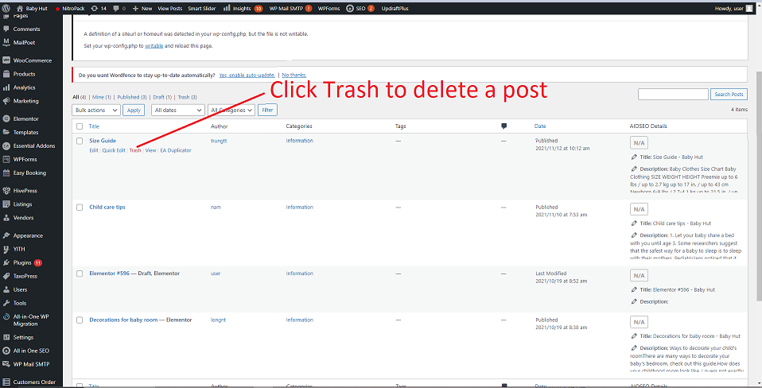

# 6. Communication with customers

We integrated 2 ways of communication with customers. One is contact form and one is live-chat with visitors. The information below will guide you to communicate with customers both ways.

## 6.1 Contact Form

### 6.1.1 Add contact us form for customers

**Step 1:** On the left-side, find and hover on **Forminator.** Then click **Dashboard.**

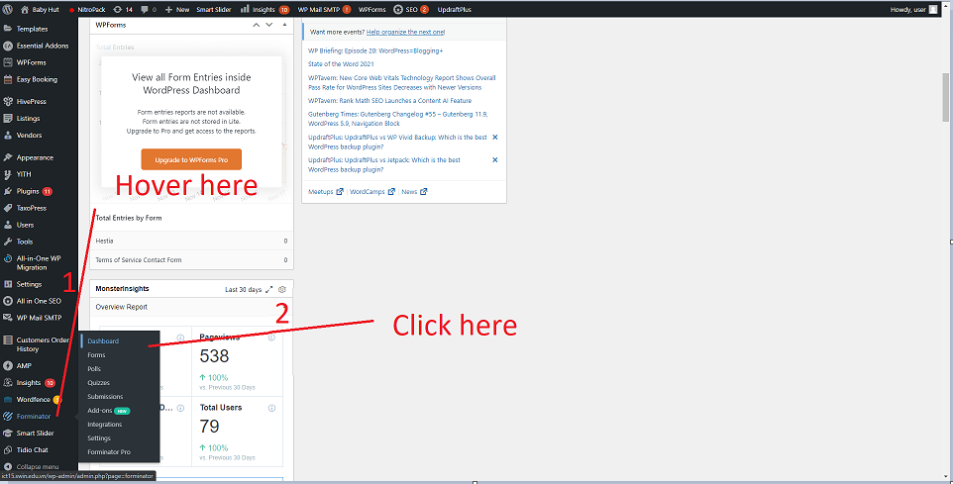

**Step 2:** You will be taken to the dashboard of **Forminator.** From here, click **Create** in the **Form** section.

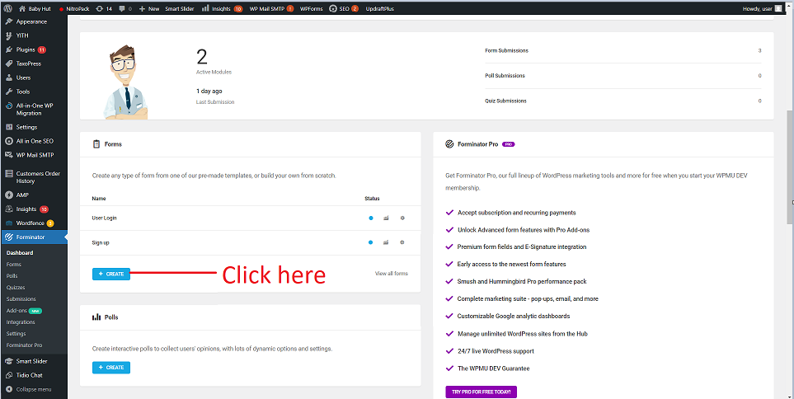

**Step 3:** A pop-up will appear, click **Contact us** template then **Continue**.

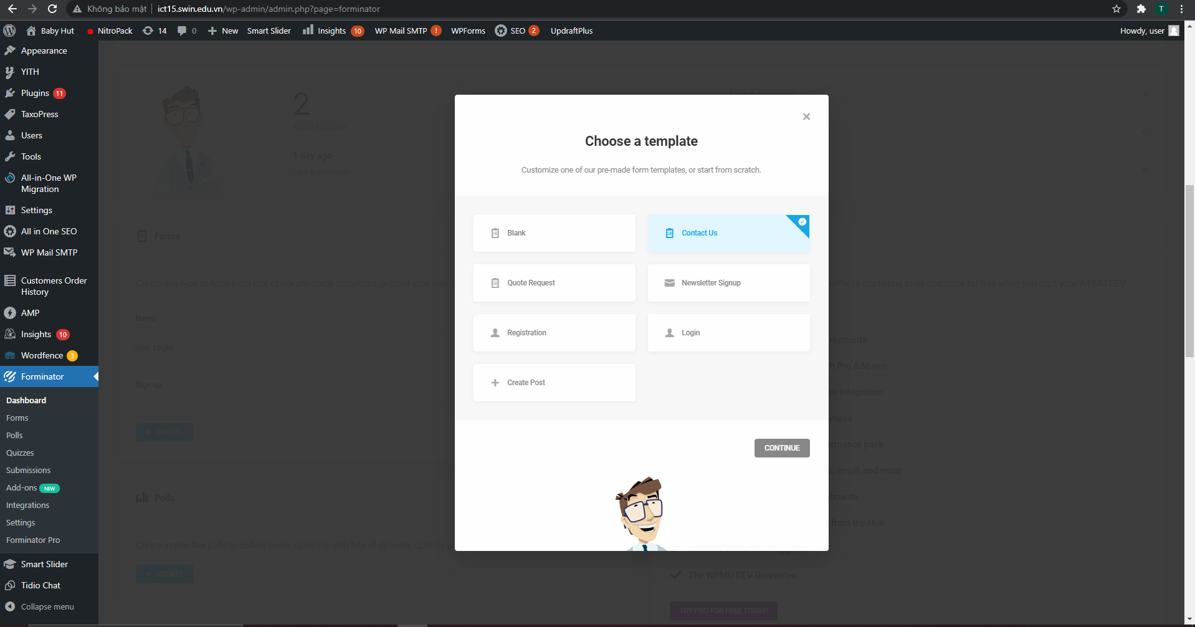

**Step 4:** Enter the name of the form, then click **Create.**

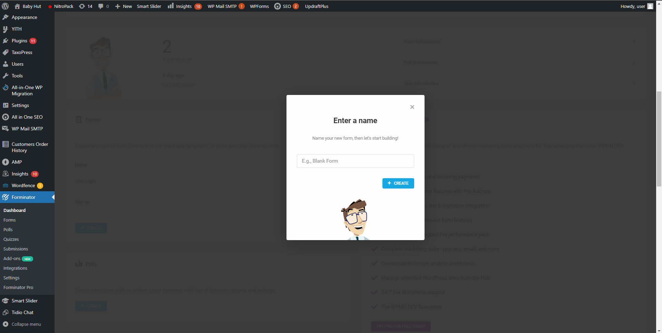

**Step 5:** You can insert fields of data you want to collect by click **Insert fields.** If your form is ready, you can either **Preview** it or **Publish** it right away.

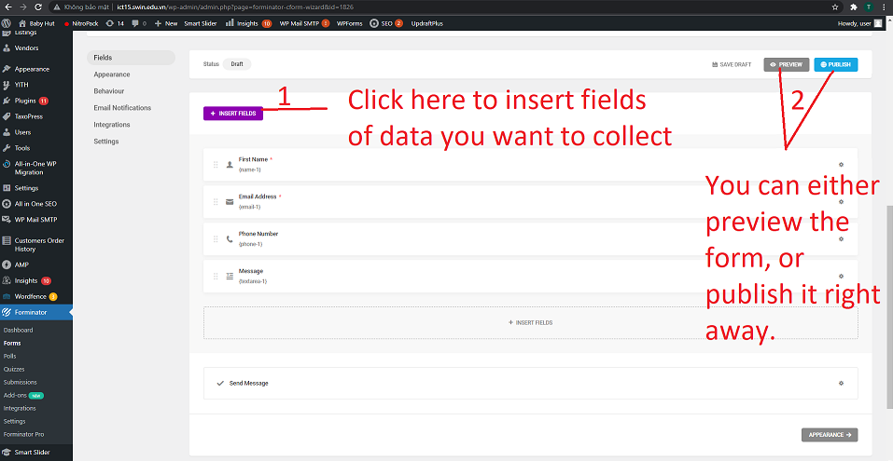

**Step 6:** After publishing, a message will pop-up with a **shortcode.** Copy the **shortcode.**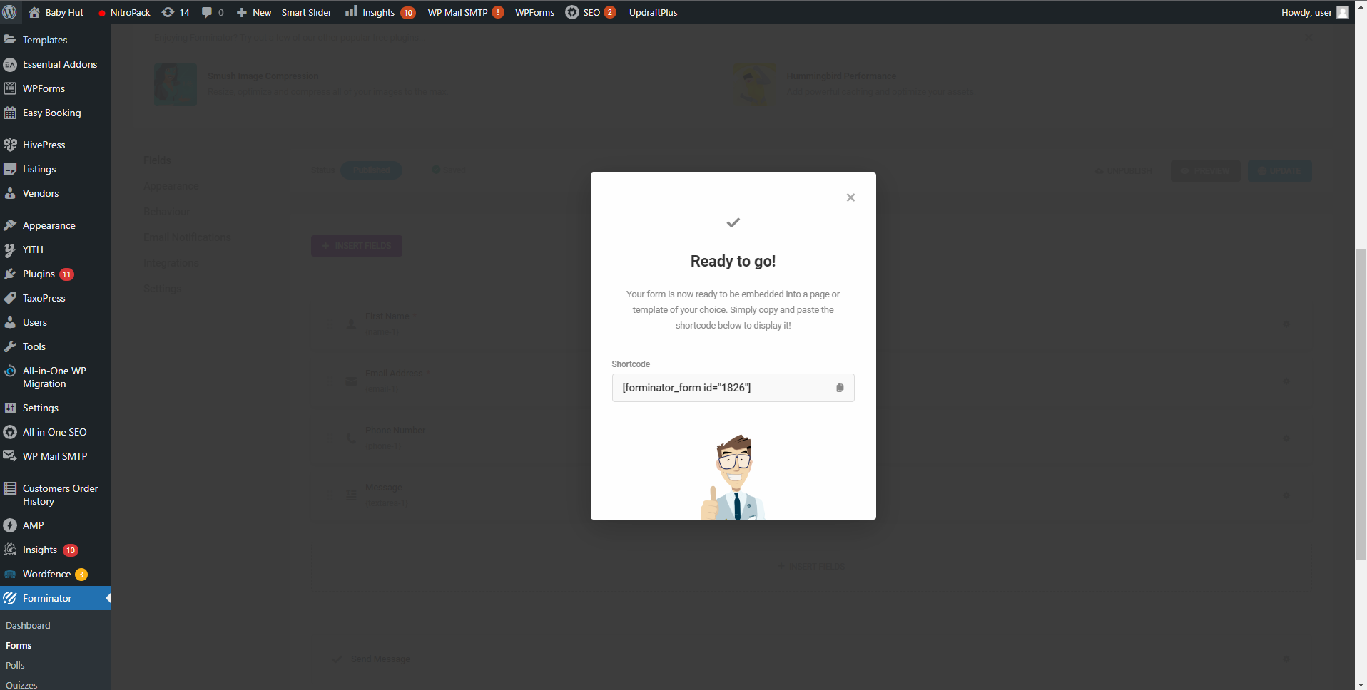

**Step 7:** On the left-side, find and hover on **Pages**. Then, proceed to click **All pages.**

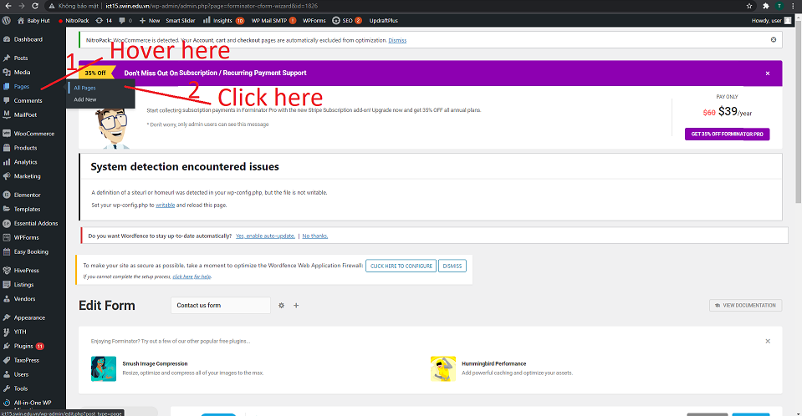

**Step 8:** Locate the **Contact us** page and click **Edit.**

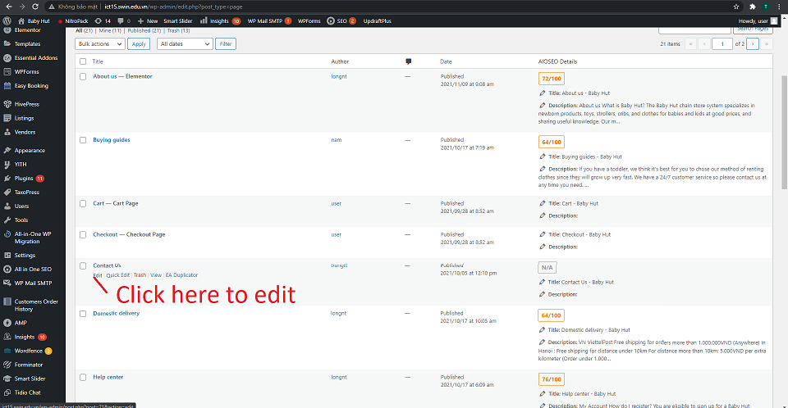

**Step 9:** Pase the **shortcode** into the big-white box. Then, click on **Update** to update the contact us page.

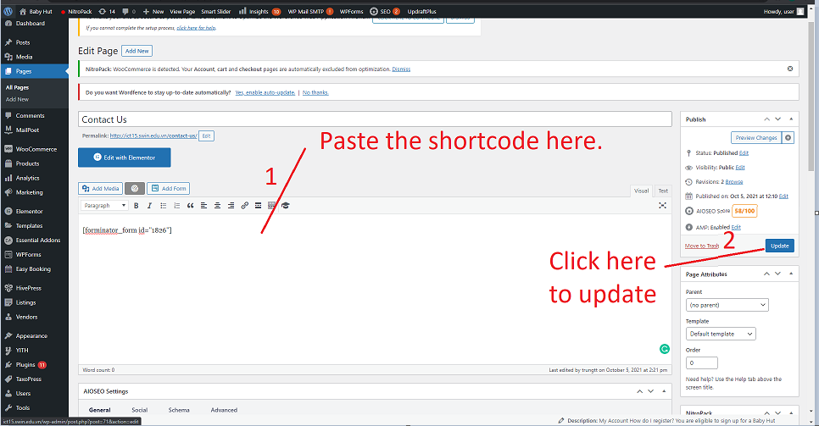

### 6.1.2 Edit contact us form

**Step 1:** On the left-side, find and hover on **Forminator.** Then click **Dashboard.**



**Step 2:** In the **Dashboard**, locate the **Contact us form,** then click on the **Gear icon** next to the contact us. Then, click on **Edit.**

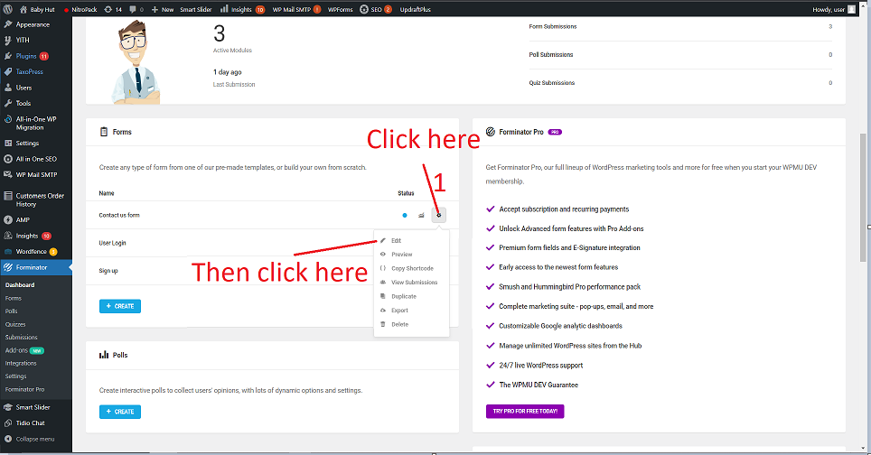

**Step 3:** Now, you can edit your form by inserting fields or changing the appearance along with other settings. For further understanding of how to use **Forminator,** please refer to Appendix #2: Guide on using Forminator. After you are done with editing, click **Update.**

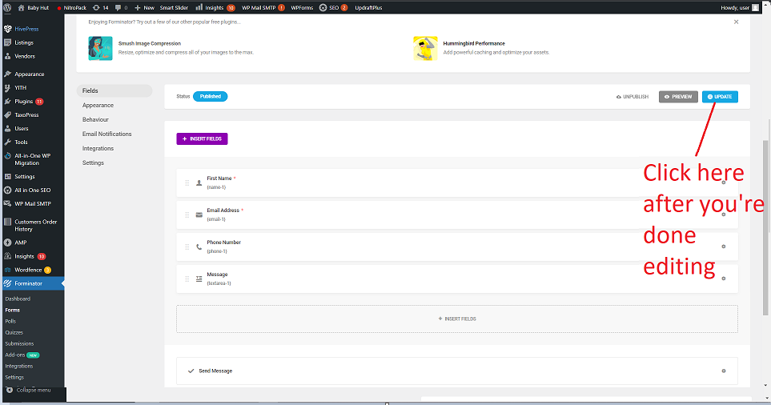

## 6.2 Live-chat

**Step 1:** Login <https://www.tidio.com/panel/login> with information provided in the **section 2. Account information.**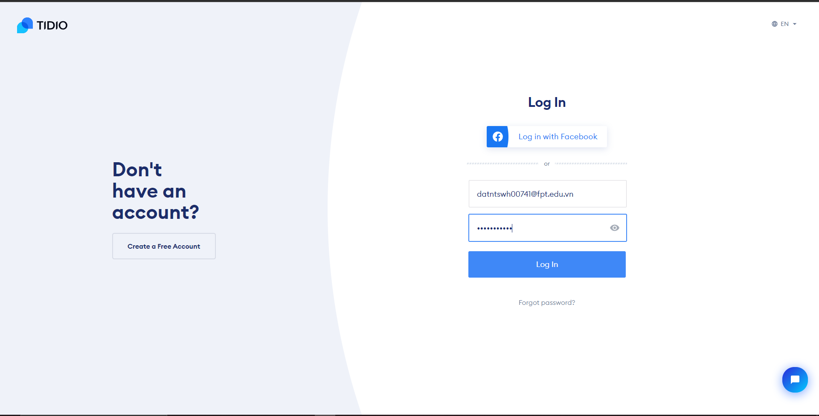

**Step 2:** Once logged in, on the left-side, click **Conversation.** 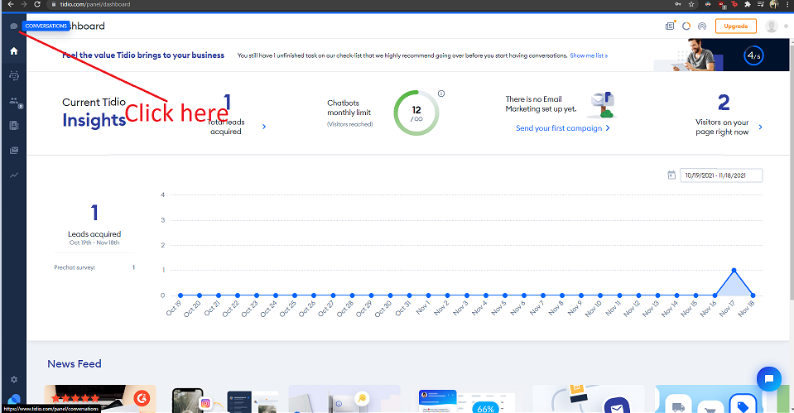

**Step 3:** Now you can chat with any customers that need help!

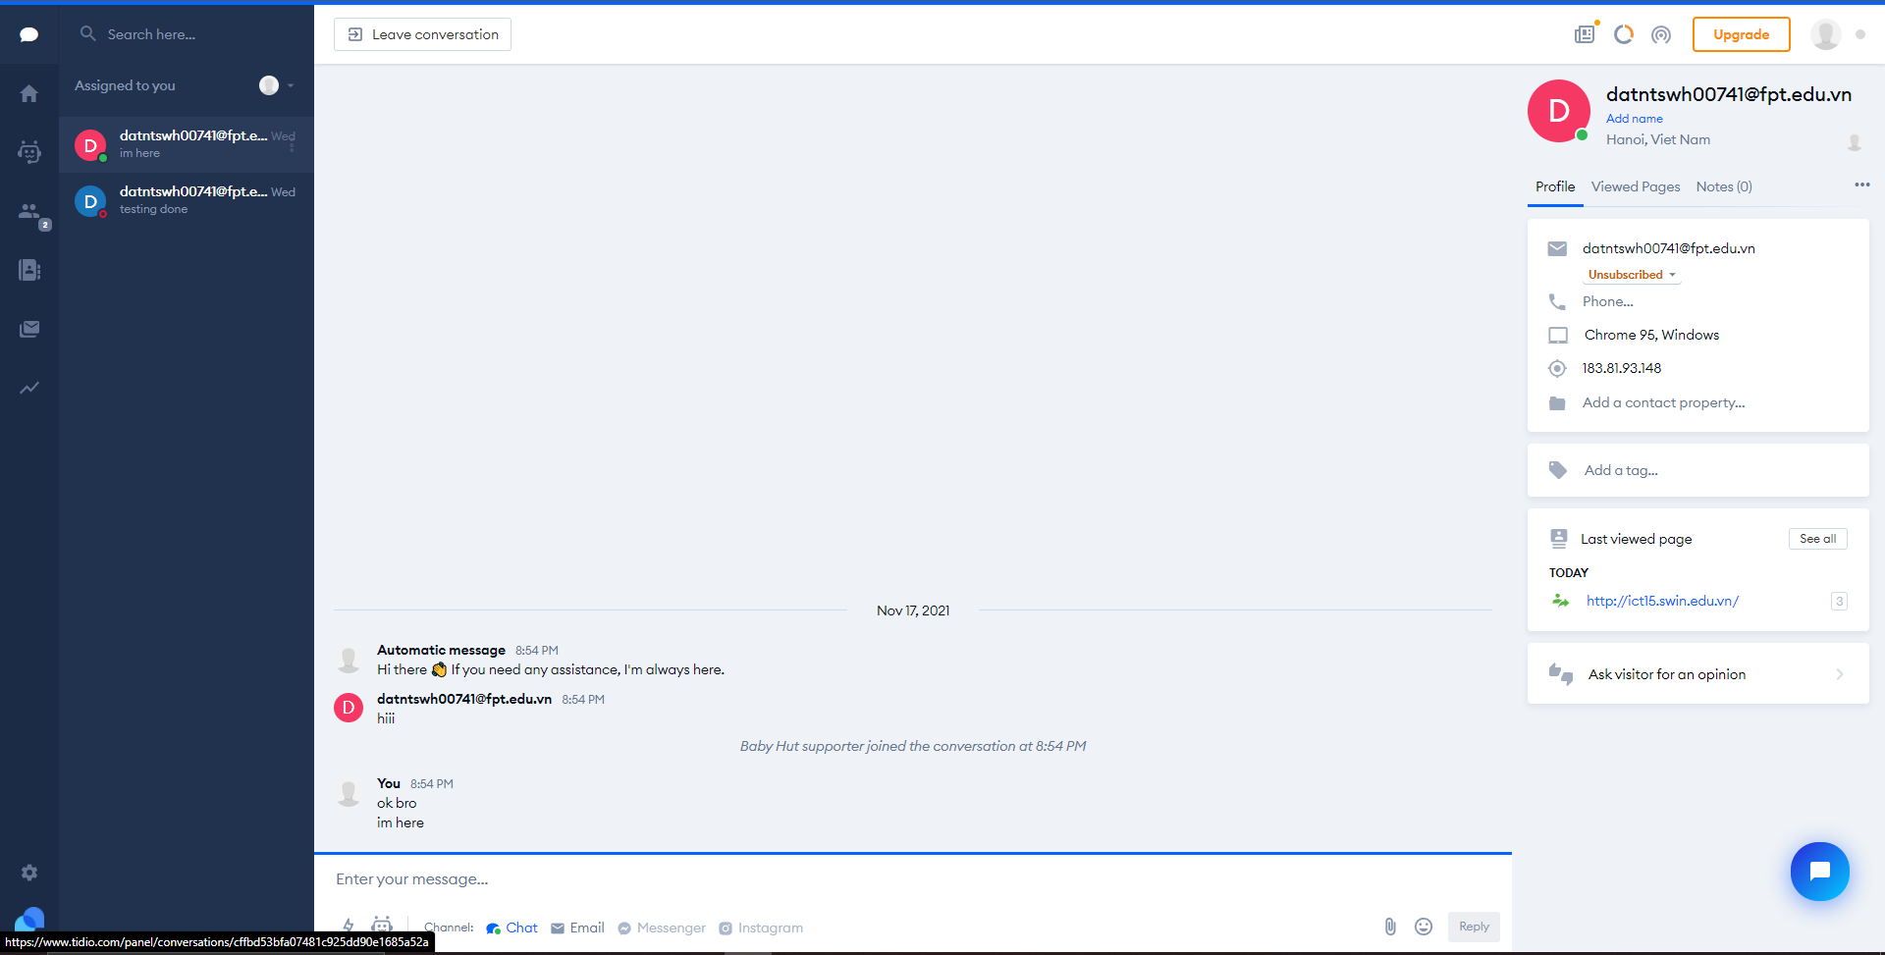

For further understanding of how to use Tidio, please refer to Appendix #3: Guide on using Tidio.

# 7. Social media with the website

The website's social networking links go to existing Facebook, Twitter, and Instagram profiles at the bottom of the page. Instead of managing these accounts on our website, users can do it using these social networking platforms.

# 8. Products management

## 8.1 Adding new products

After successfully installing WooCommerce, you will see a tab labeled **WooCommerce** on the left side dashboard menu.

In order to add products, go to **Products > Add New**

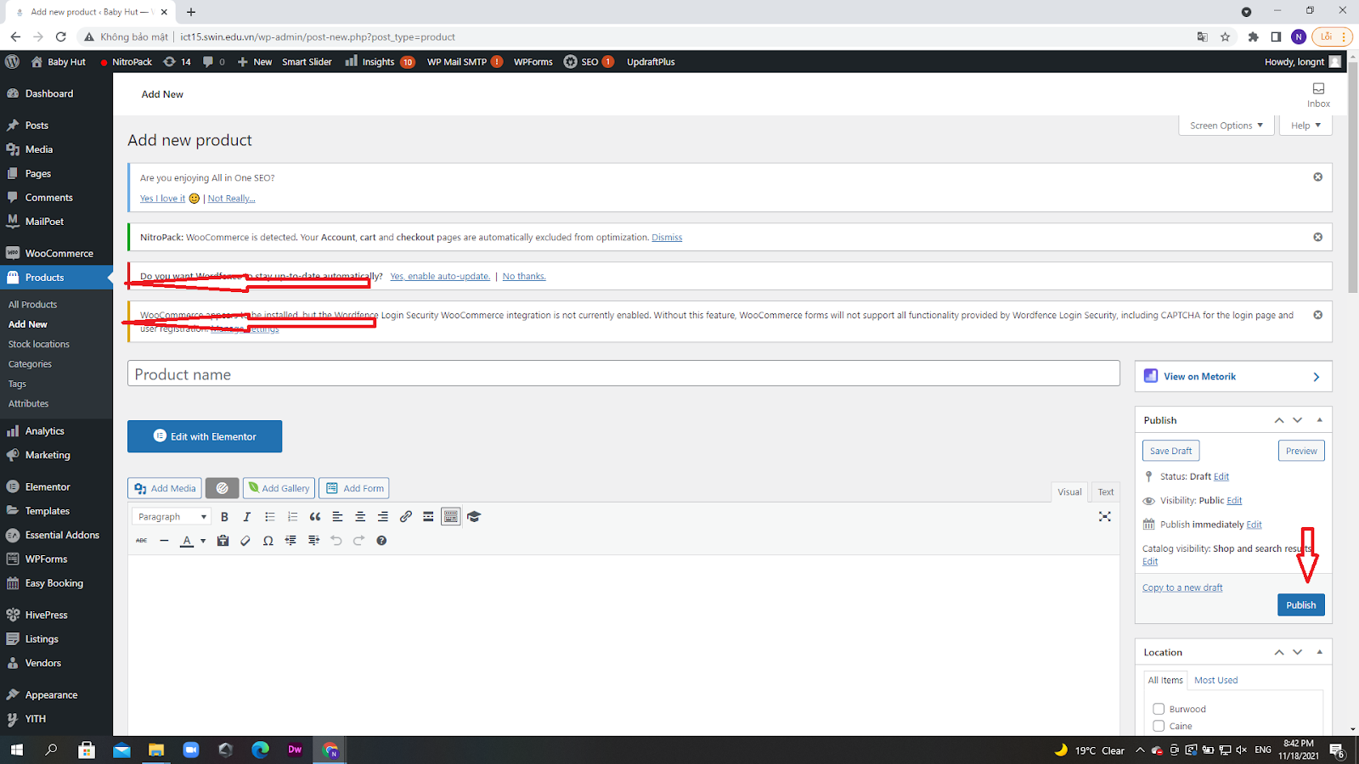

You will want to enter the products’ description as well as titles

Take a look at these images.

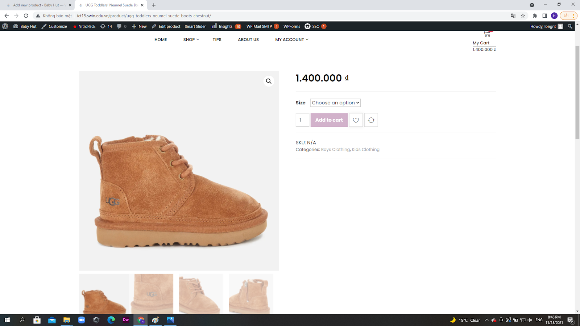

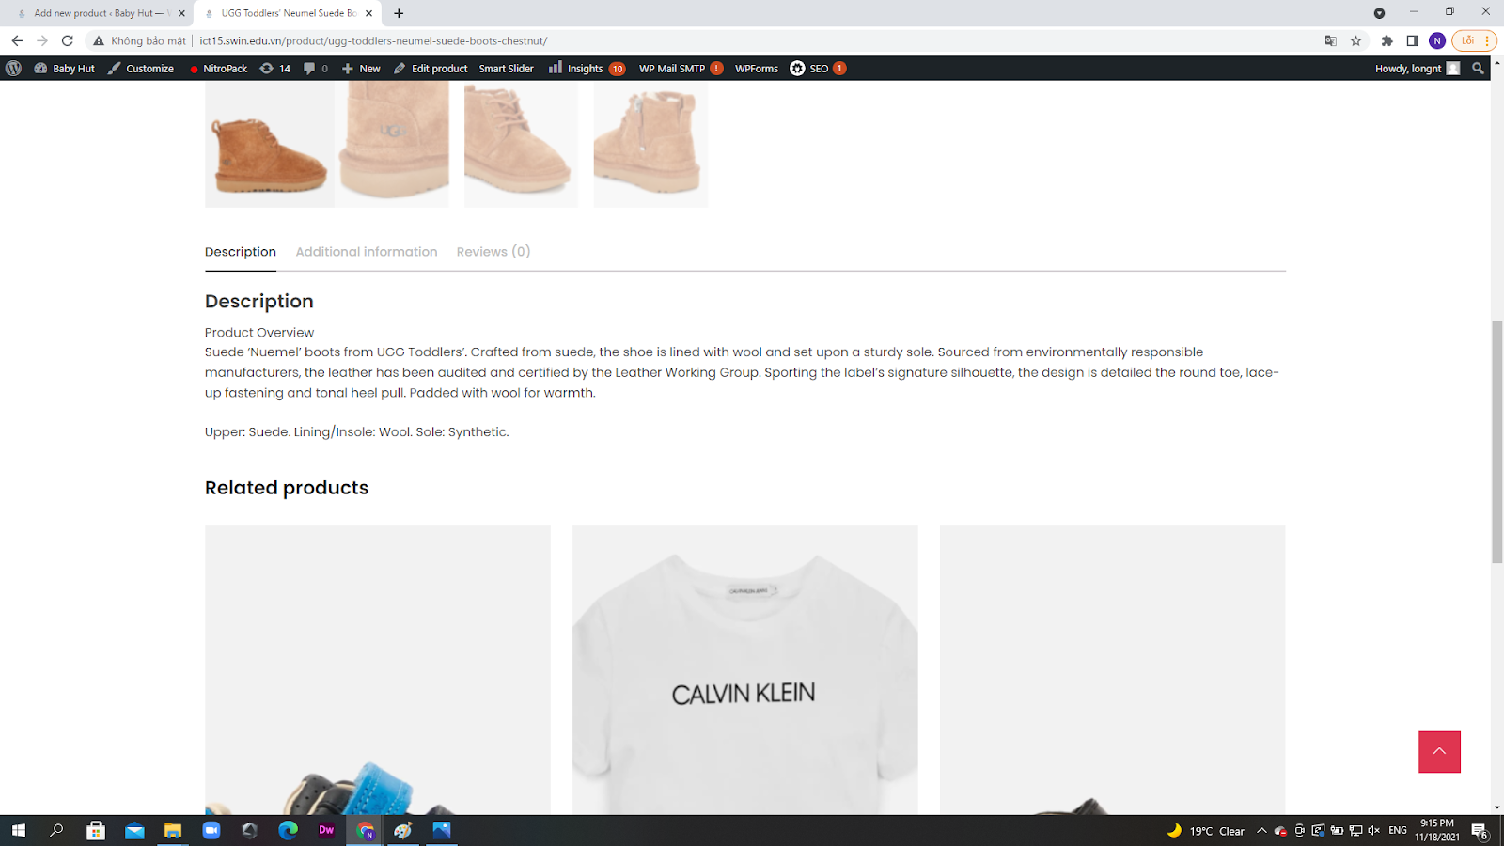

Next up, you will want to add your products information to WordPress

We will see how to do that with the steps below.

## 8.2 Adding information to your newly added products

You will see this **Product data** section when scrolling down:

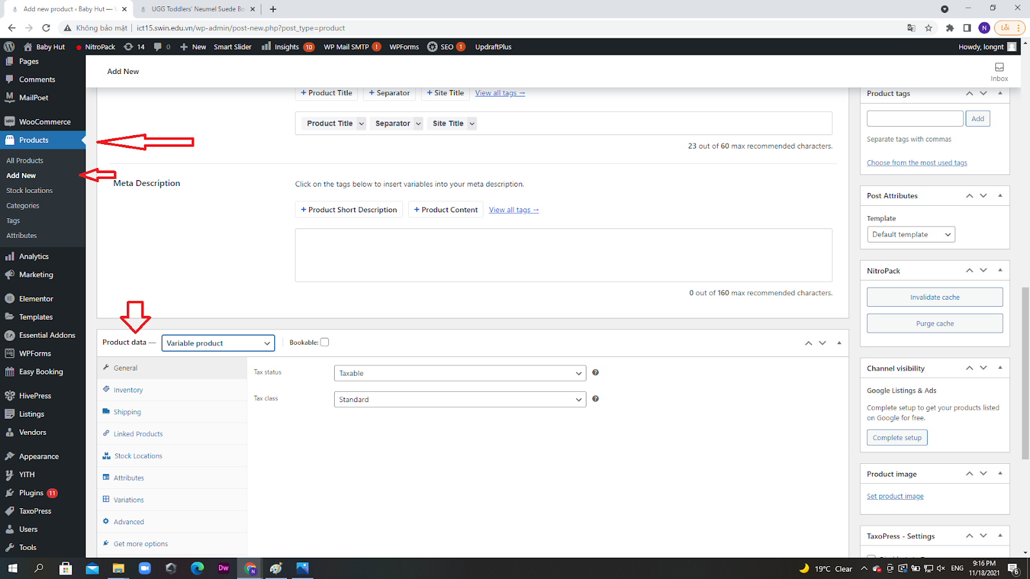

Now you can add all kinds of details to your products, at the very top, you can choose a product to be virtual (which removes the shipping tab) or not.

In **General** tab, you can enter the sale(time sensitive) and regular price

Image as below:

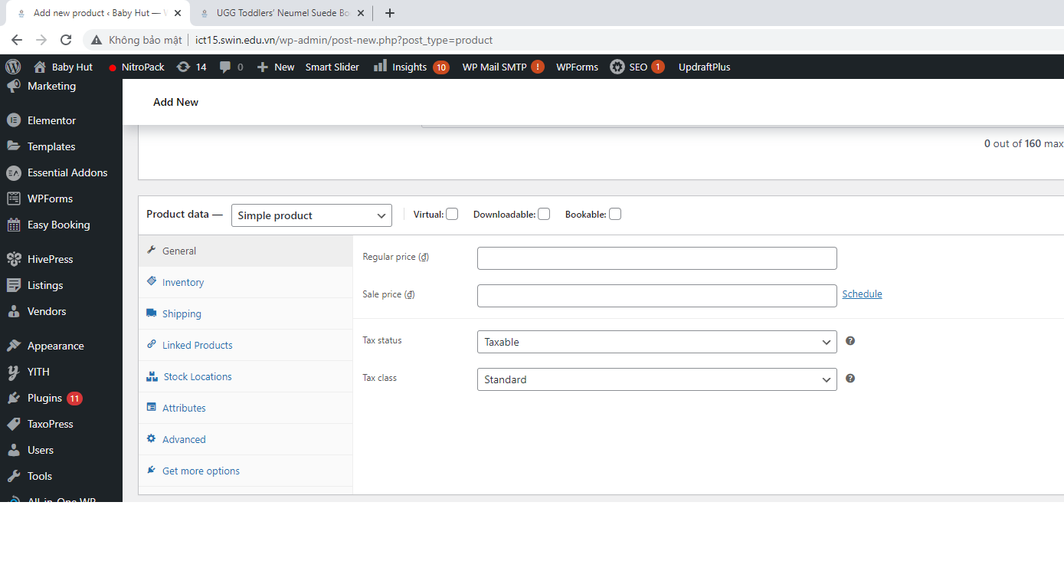

Next, see **Inventory** tab where you can manage the stock by typing in the quantity of products, stock availability (sold out/in stock).

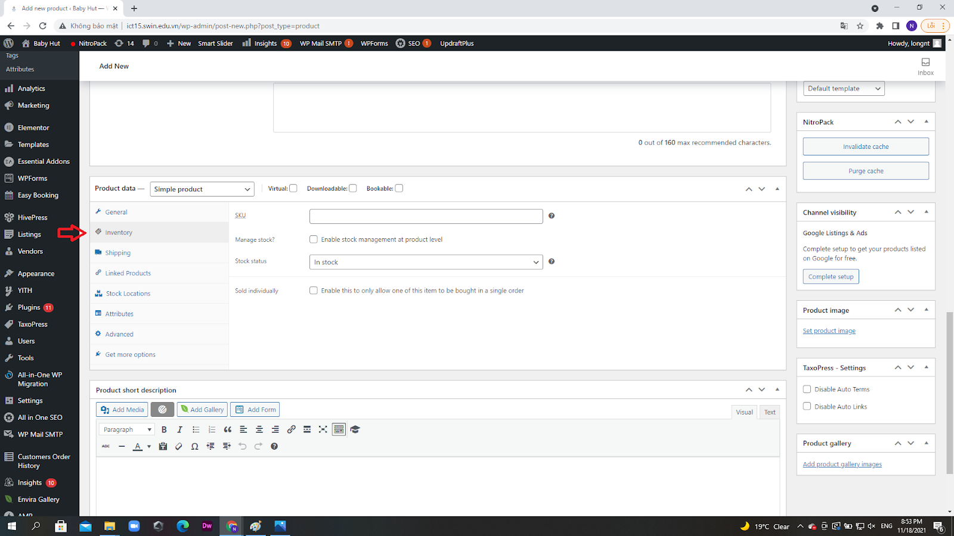

You can also choose the product to be individually sold ( only one bought at a time) and enter the product ID numbers (SKU).

There are other tabs here as well, the first one is the **Shipping** sectionwhere you can enter extra information like product weight, dimensions, or types.

In the **Linked Products** tab, you can select upsells or cross-sells.

**Attributes** tab allows you to add the product’s characteristics.

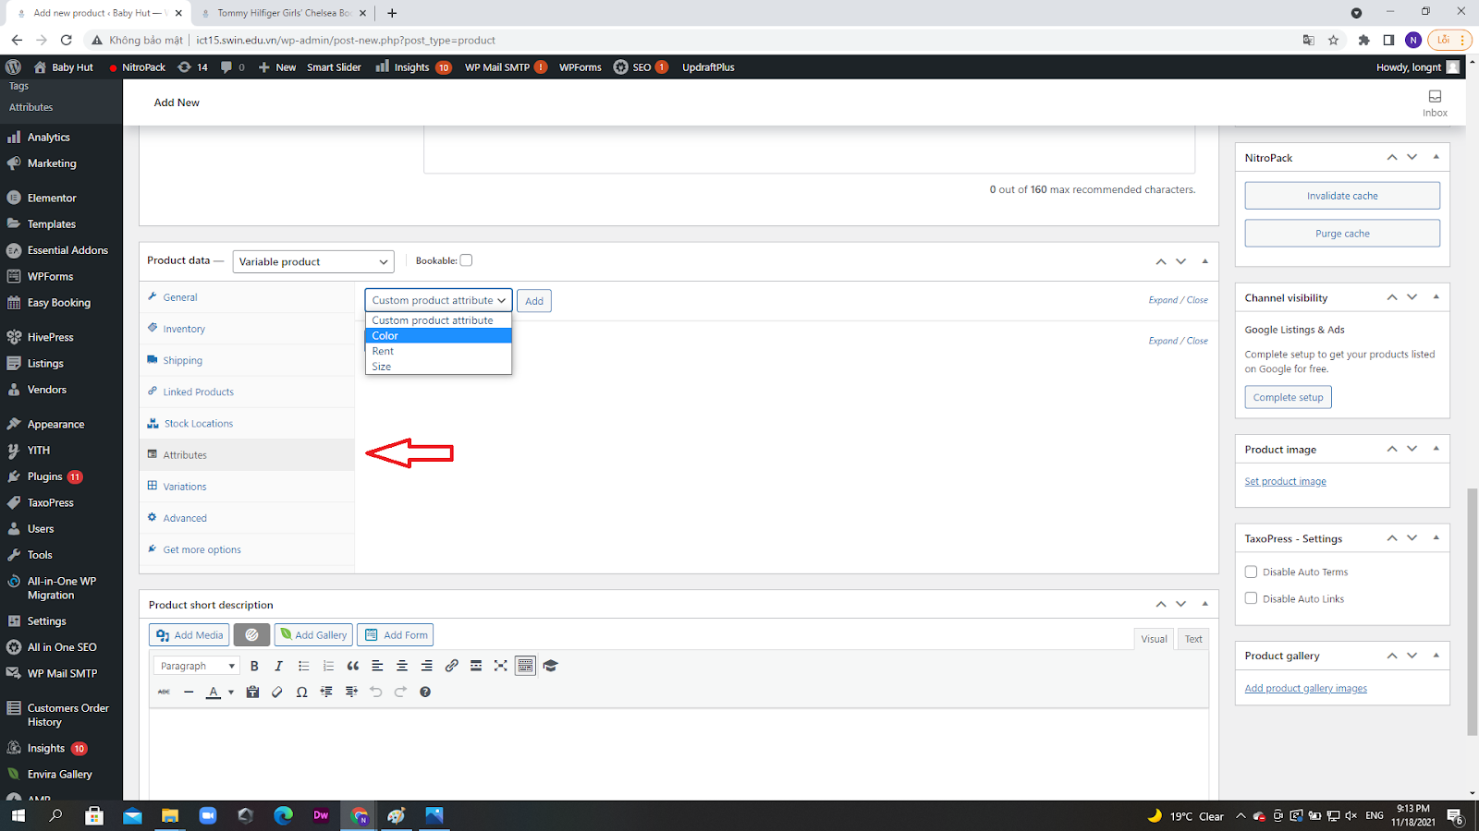

Finally, in the **Advanced** tab, you can add purchase notes as desired or determine a product’s fixed position on the page and enable reviews. If you want more options, you can take a look at the **Get more options** screen.

## 8.3 Creating Variable Products and Attributes

There are lots of options for adding information to products.

Let’s take a look at the most useful options in the **Product data** section: Attributes and Variable products.

Attributes are important descriptions for your product as they tell customers vital information.

This includes size, weight, color, material, etc. This information will be displayed on the product page.

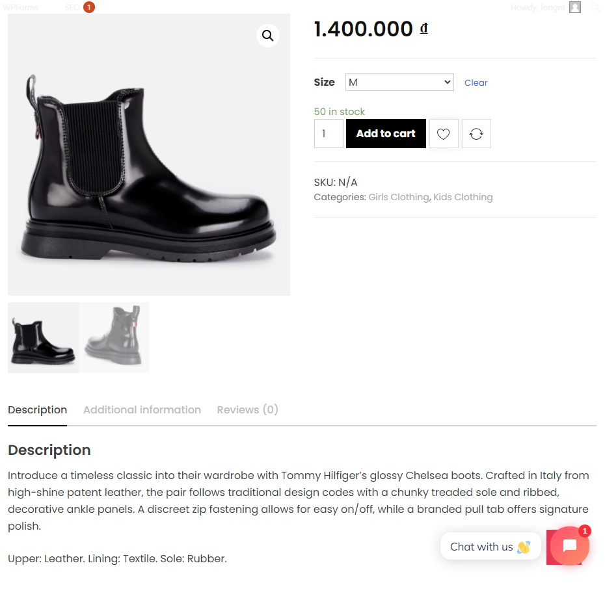

If the products come in multiple options then you can select the **Variable product** tab to add varieties of the same product, for example varying cloth sizes like S, M, L, XL. And then give each version their own price tag, descriptions, and so on.

This information will be available on the product page.

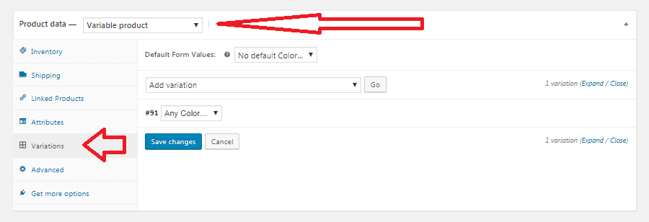

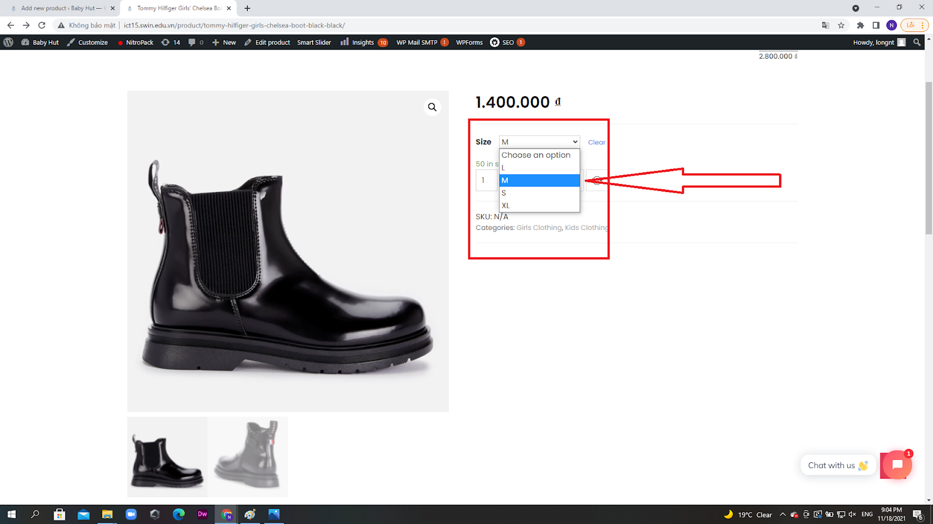

This allows customers to find the desired products easier without creating extra pages for the same product.

## 8.4 Product Short Description guide

Under the **Product Data** widget, you will see a section called **Product short description:**

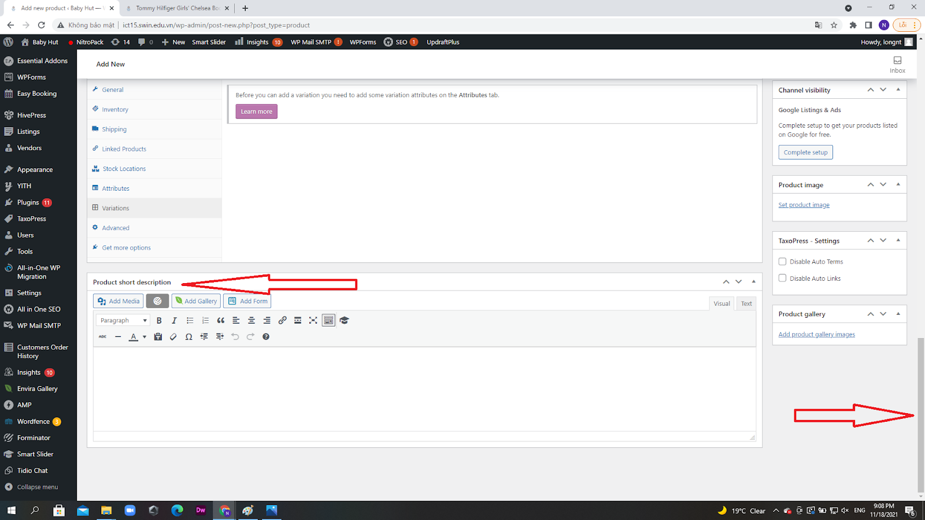

Here you can add your short description about the product, this will be displayed under the product’s name. Also, you can use this description to highlight the main selling points and features of the product.

This tab allows you to add tags, categories, logos, or images to your product.

Here is what the product short description should look like on the screen:

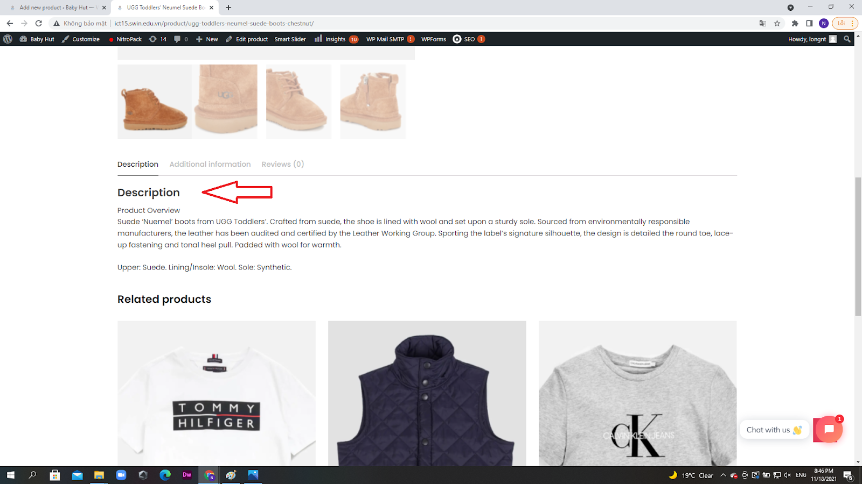

Once finished, click the **Publish** button to save the changes

## 8.5 Managing WooCommerce Products

Look for the **Product** tab in the left side Dashboard, now you can manage the items easily using a board as below:

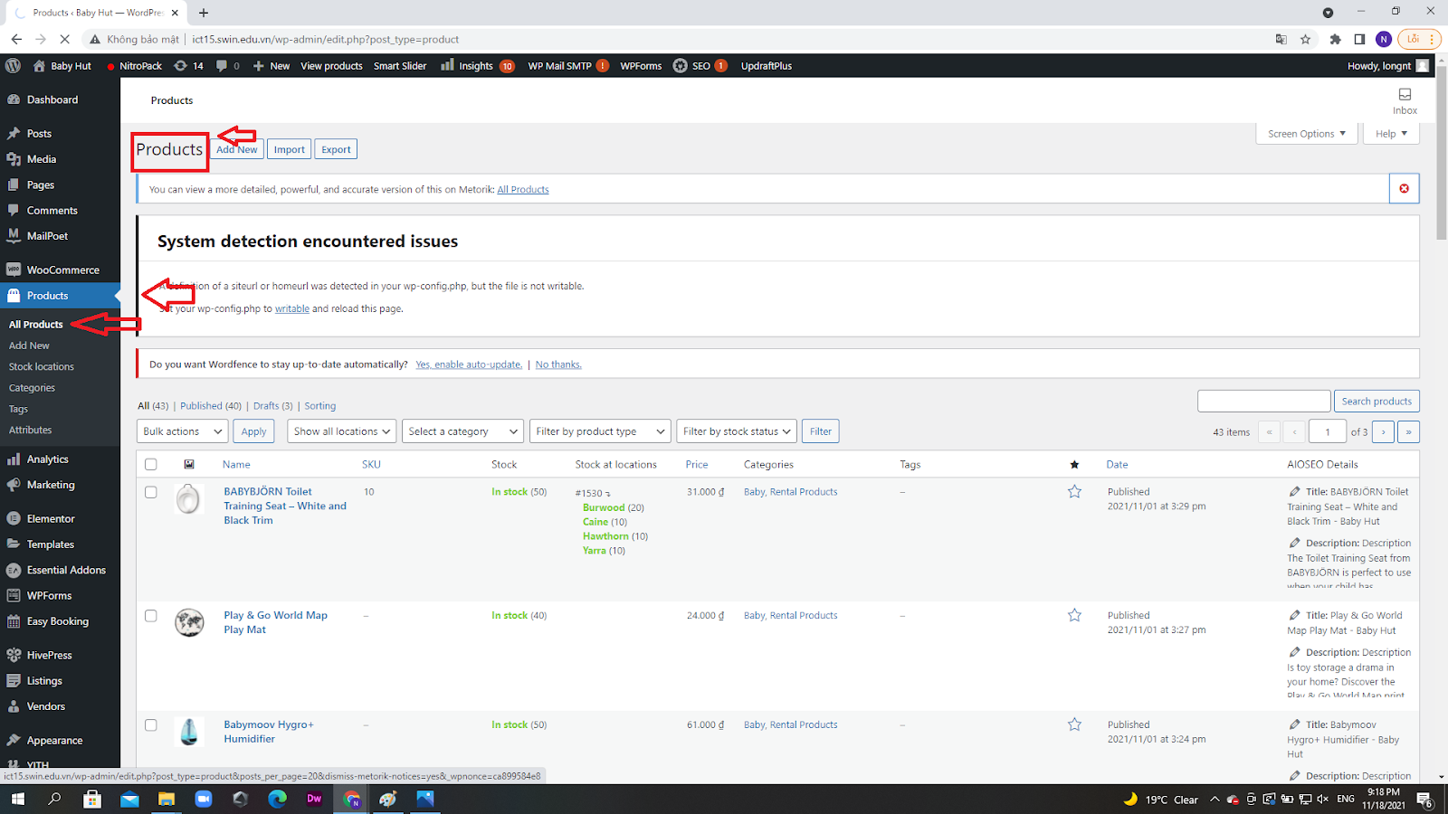

You can select **All Products** to see every item available on your product page.

You can add, delete, edit products as desired.

Under the **Products** section, you can view attributes, categories, tags of products.

# 9. Using website analytics

## 9.1 Overview

Scroll down and look at the left side, you will see the **Analytics** tab

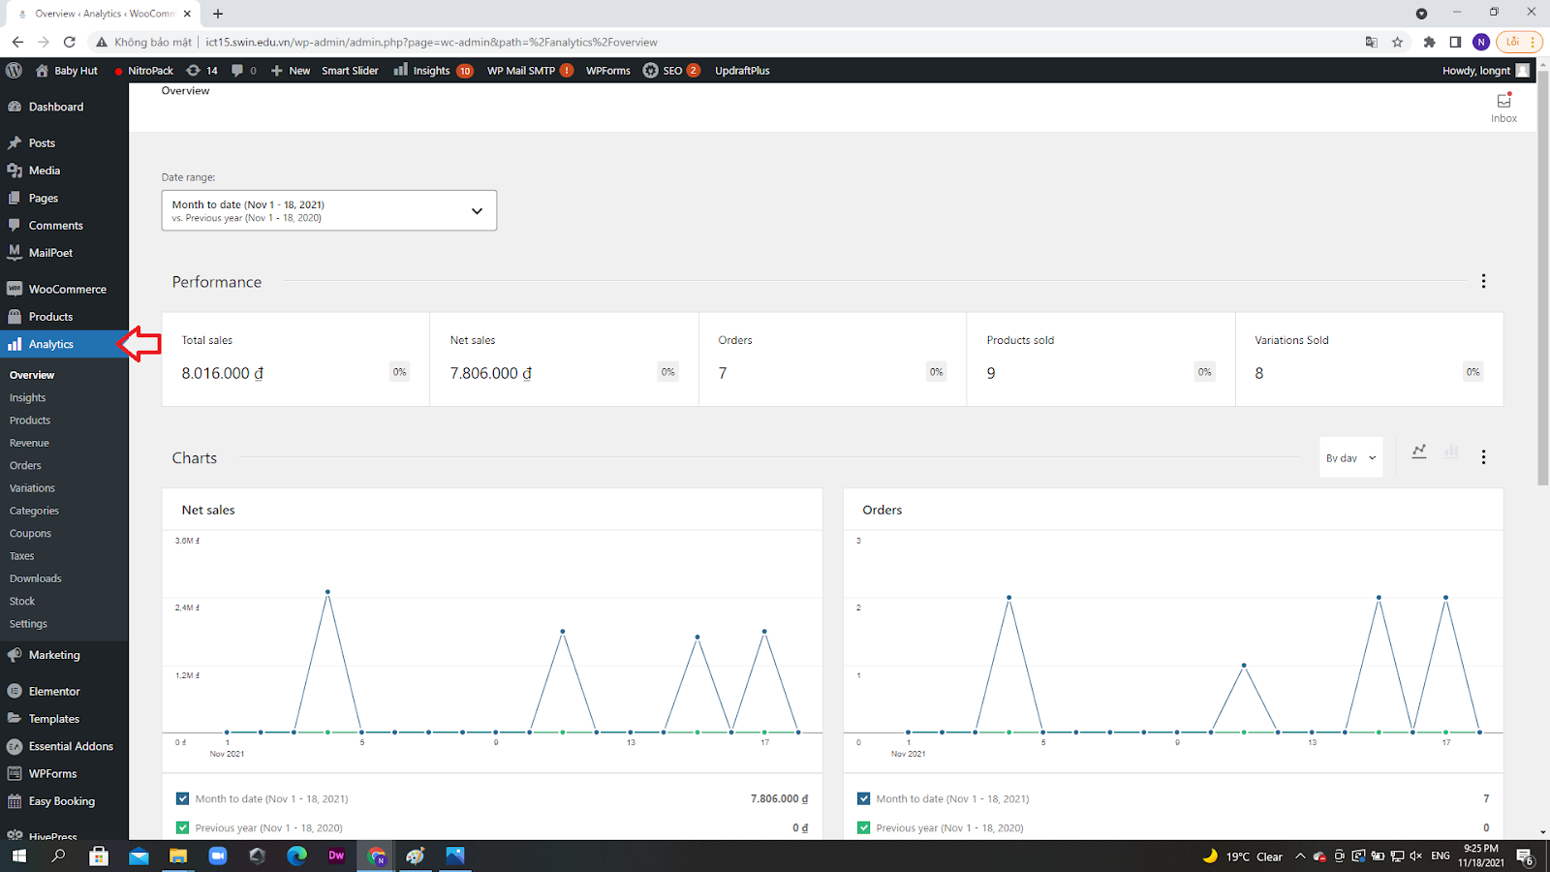

Make sure that you log in first for the Analytics tab to work.

## 9.2 Viewing traffic number

Scroll down, look at the left-hand side for the **insights** tab, choose **Reports**

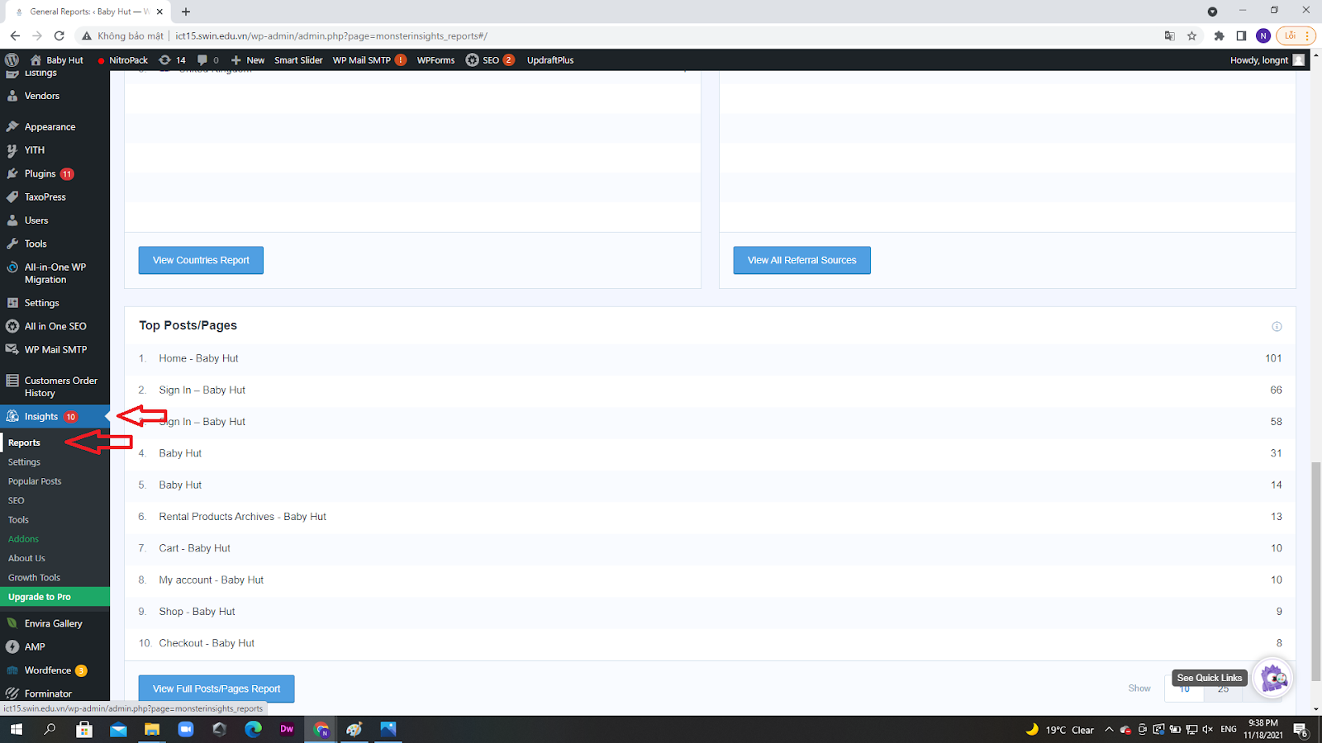

Now you can see the numbers of users on the website as well as other breakdowns of detailed reports.

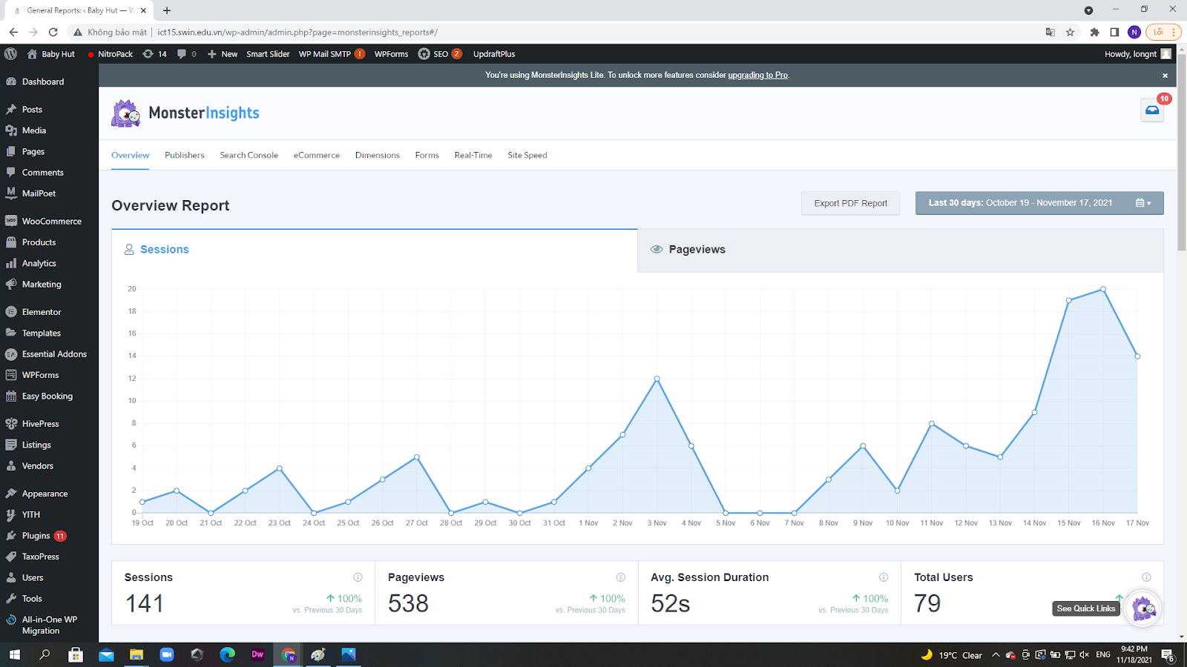

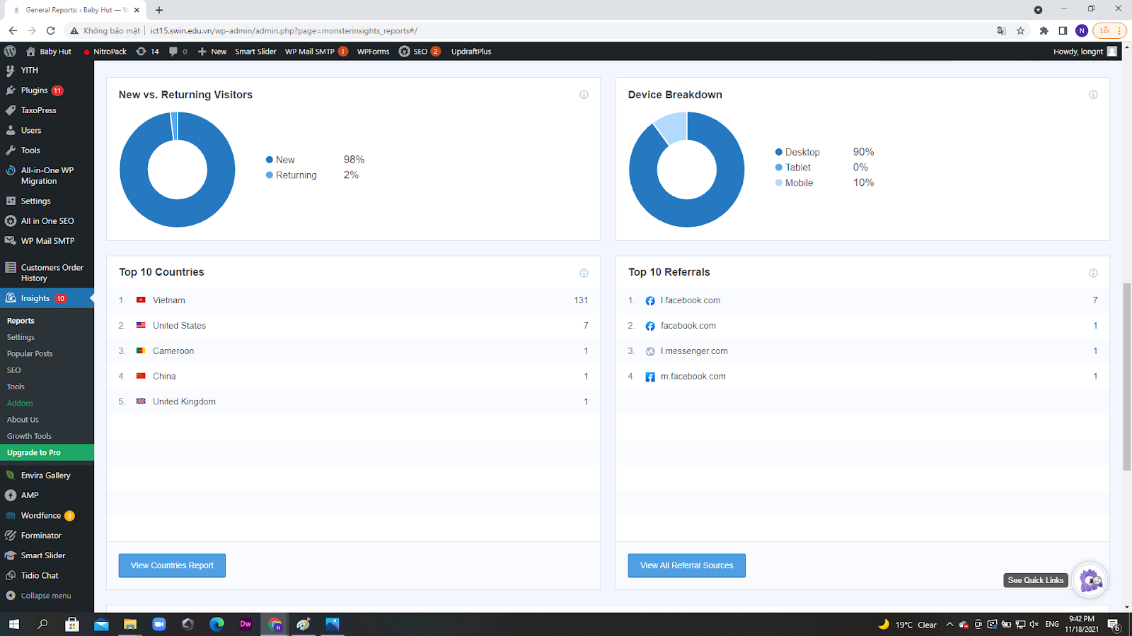

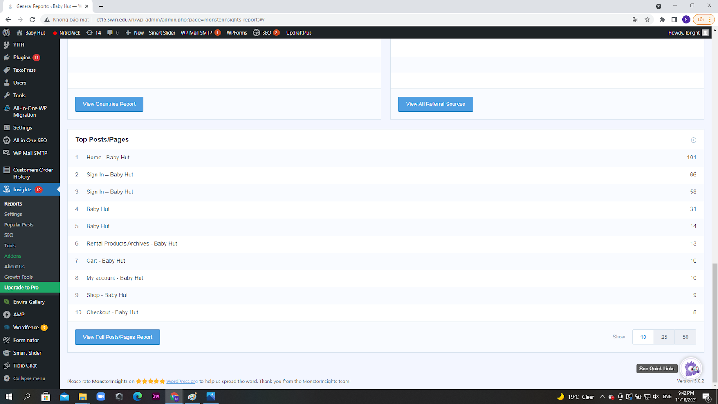

# 10. Generating Back-ups

## 10.1 Why should I Backup ?

Backup your website is very important to prevent random events like the loss of website mainframe and data as well as confidential user information. Anything can happen so it’s best to save a version of your website and data every period of time.

Take a look at what are the causes of website loss:

* Exploitation: Your website is illegally accessed or attacked by hackers or employees from the inside, they could intentionally delete or steal important information to gain benefits.
* Human error: Someone accidentally deletes important data.
* Random events: Natural disasters, accidents, hardware errors, etc.

As you can see, it is always good to have backups to prevent data and website loss.

## 10.2 How often should I Backup ?

Once every month is recommended or you can backup whenever you feel something is not right, this is totally fine. Also, try to make backups before implementing new features ( plugins, layouts, functionalities, etc) to prevent undesirable results when something goes wrong as it allows you to rotate to the former versions of the website. If the website experiences increased traffic flow, it is best to extend the backup time period to one and a half or two months. Make sure that you have extra backups in case of original backups loss.

## 10.3 Where should I store the backups?

It is advised to store backups at your office computers or servers, extra copies stored at home databases ( PC, Laptop, etc ) are also recommended.

## 10.4 How can I back-up my website?

**Step 1:** Log in to WordPress administration page as guided in **section 4.**

**Step 2:** On the left-side, find and hover on **Settings,** then click **UpdraftPlus Backups.**

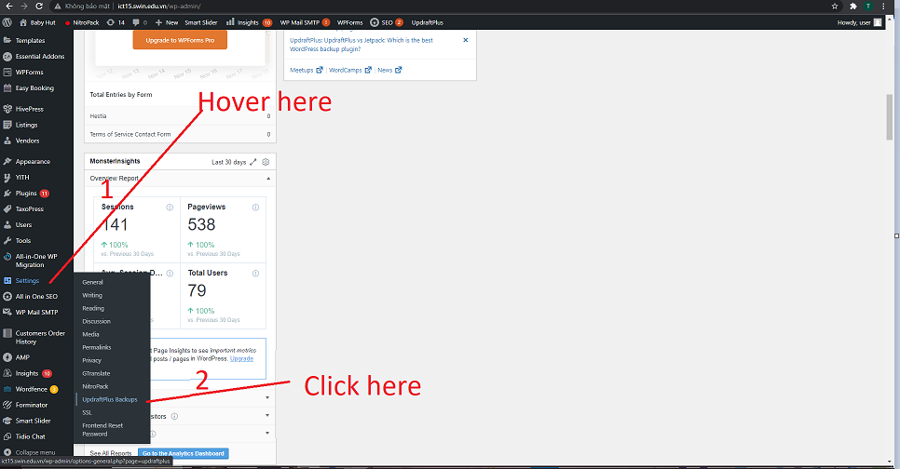

**Step 3:** Click **Backup Now** to back up your site

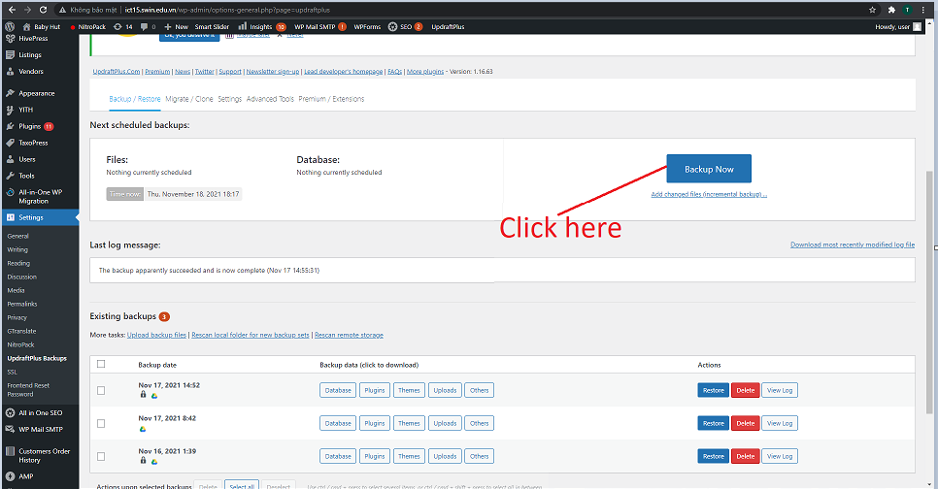

## 10.5 How can I restore my website?

**Step 1:** Follow step 1 and 2 in **section 10.4.**

**Step 2:** Click **Restore** on the desired version of the web.

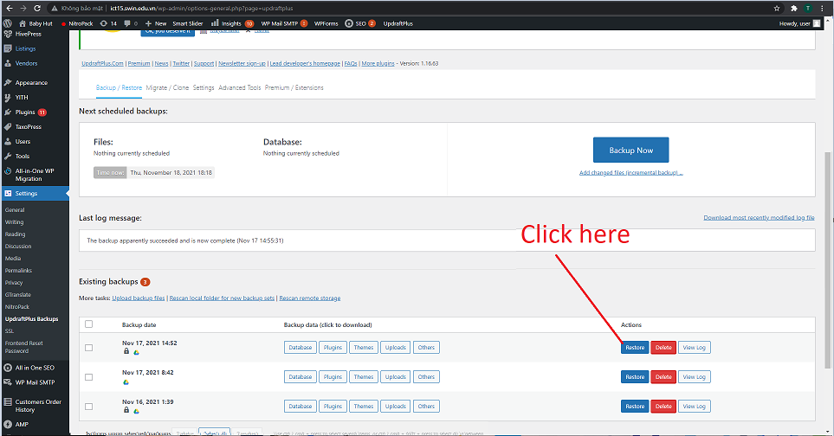

# 11. Reports generation

## 11.1 Overview

Through development, we managed to generate most of the required reports with 5 different plugins. This section will provide information on which plugin is capable of generating which report.

## 11.2 Metorik plugin

### 11.2.1 Login

**Step 1:** Login <https://app.metorik.com/login> with the account information provided in **section 2. Administrative information.** After filling in the information, click **Log in**.

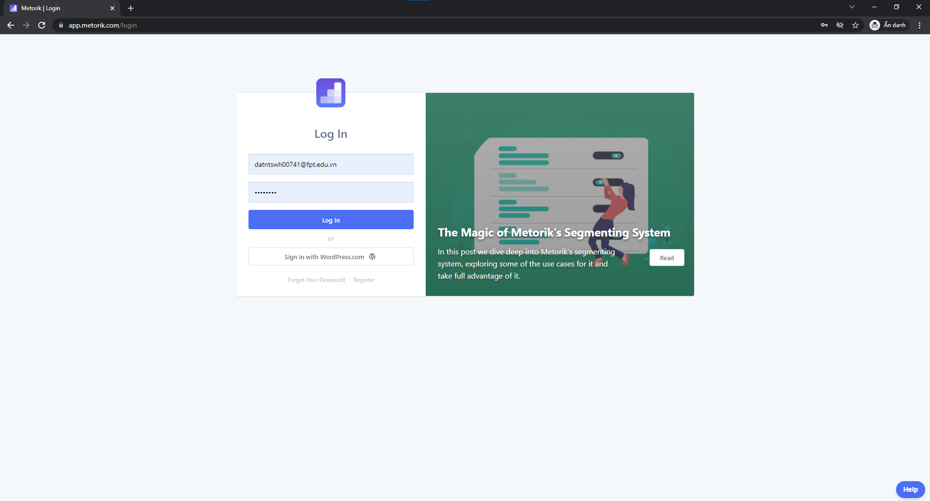

**Step 2:** After logging in, click on the **Dashboard** on the left of the site. It will take you to the Dashboard section to have an overview of sales analysis.

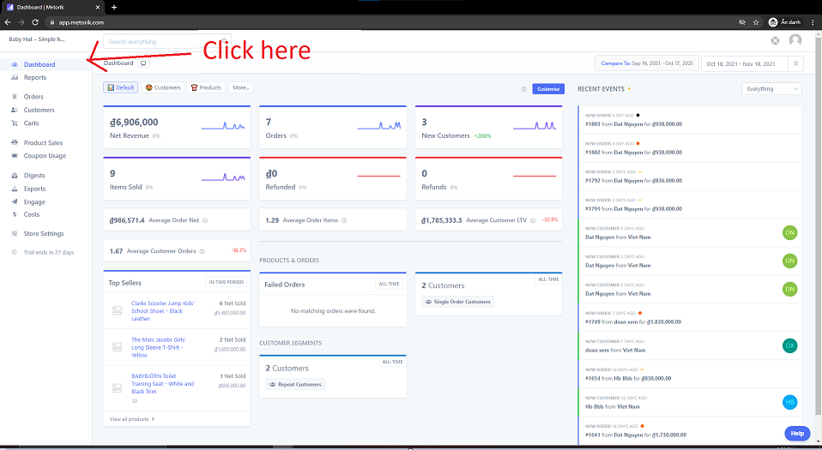

Besides the general analysis of sales, Metorik is capable of generating **Member lists** and **Sale analyses** as required by the client.

### 11.2.2 Member list report

**Step 1:** From the main page, navigate to **Customers.**

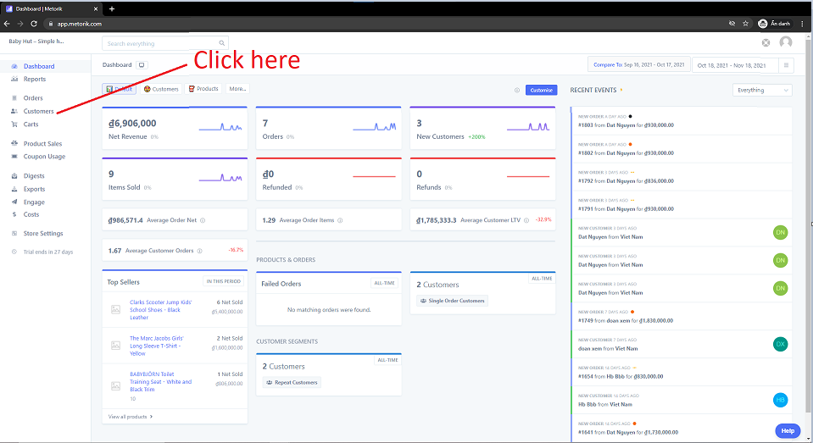

**Step 2:** From there, click **Choose a segment** on the top right.

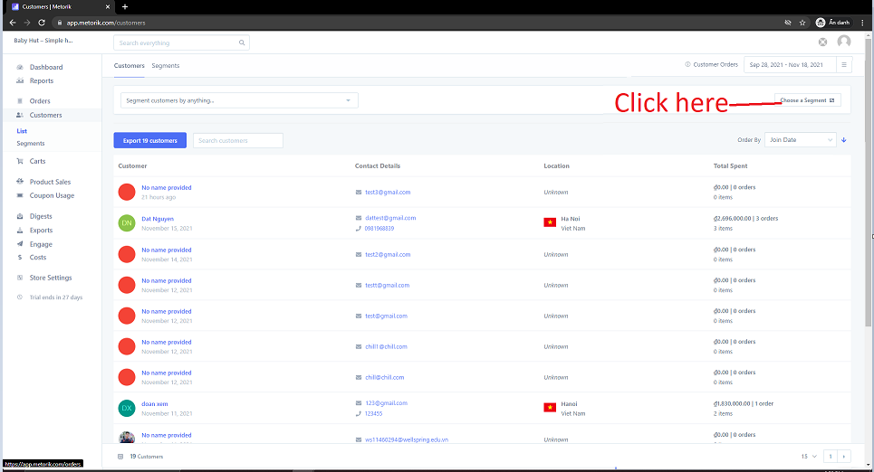

**Step 3:** A drop-down box will appear. Click **Users**

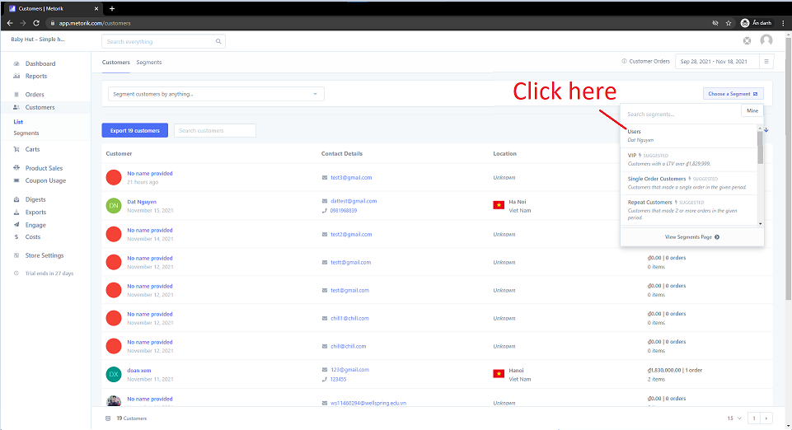

**Step 4:** A web version of the list will appear. From there, you can choose to **Export.**

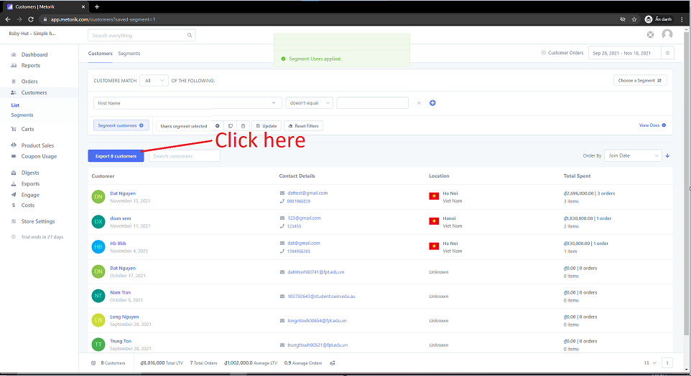

**Step 5:** Click **Download Export** or **Email Export to Me** to get the excel version of the list.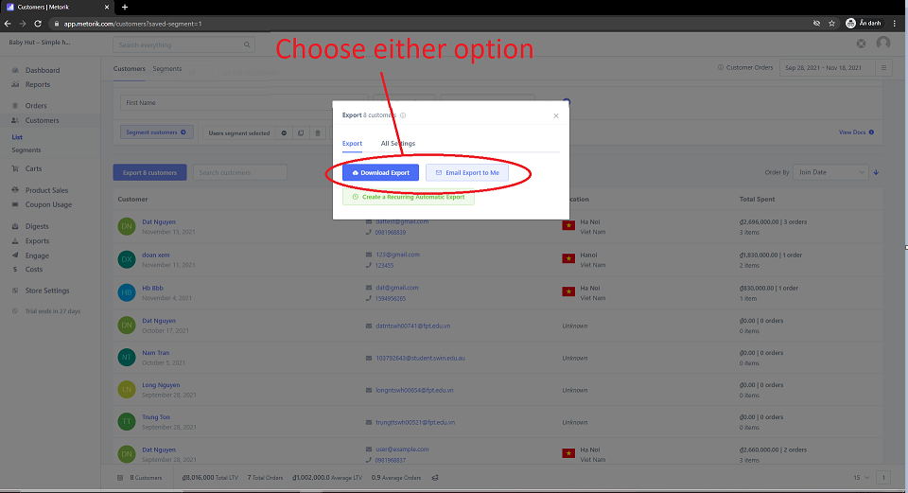

**Step 6:** Open the file. Here is an example of the excel version, there are more attributes on the right.

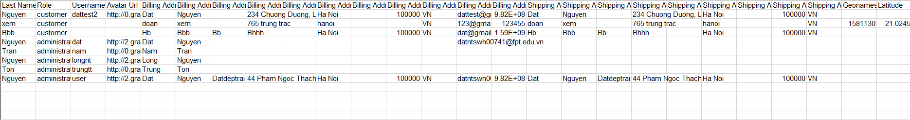

### 11.2.3 Sale analysis report

**Step 1:** Navigate to **Product Sales** on the navigation bar. Then click on **Products** right under **Product Sales**.

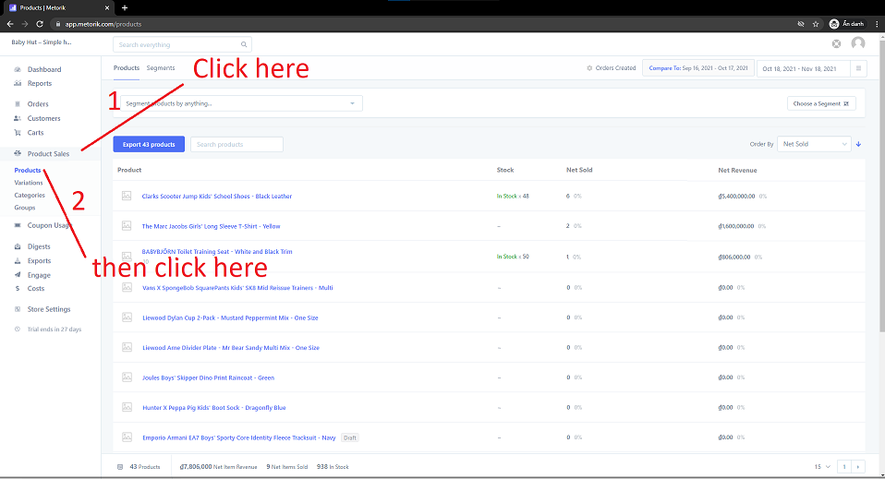

**Step 2:** Now you will see a web version of the report. To download the Excel version, click **Export.**

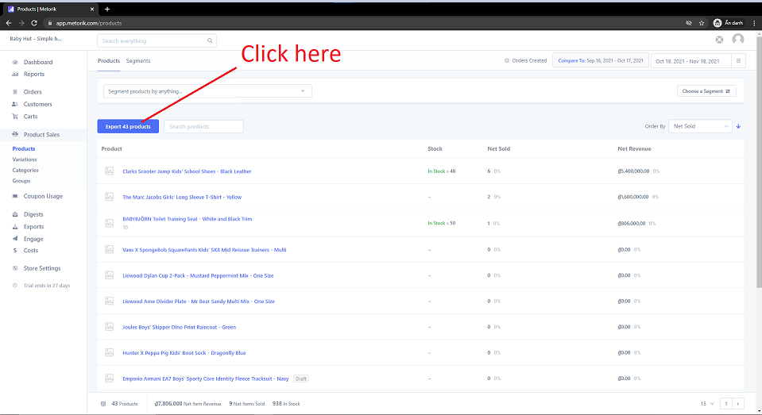

**Step 3:** Click **Download Export** or **Email Export to Me** to get the excel version of the list.



**Step 4:** Open the file, here is an example of the Excel version.

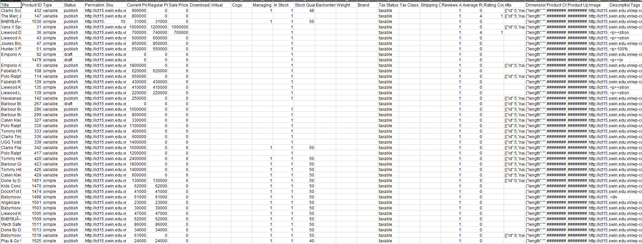

## 11.3 WordPress plugins

### 11.3.1 Login

**Step 1:** Navigate to <http://ict15.swin.edu.vn/wp-admin> and fill in the account information provided in **Section 2. Administrative information.** After filling in the information, click **Log in.**

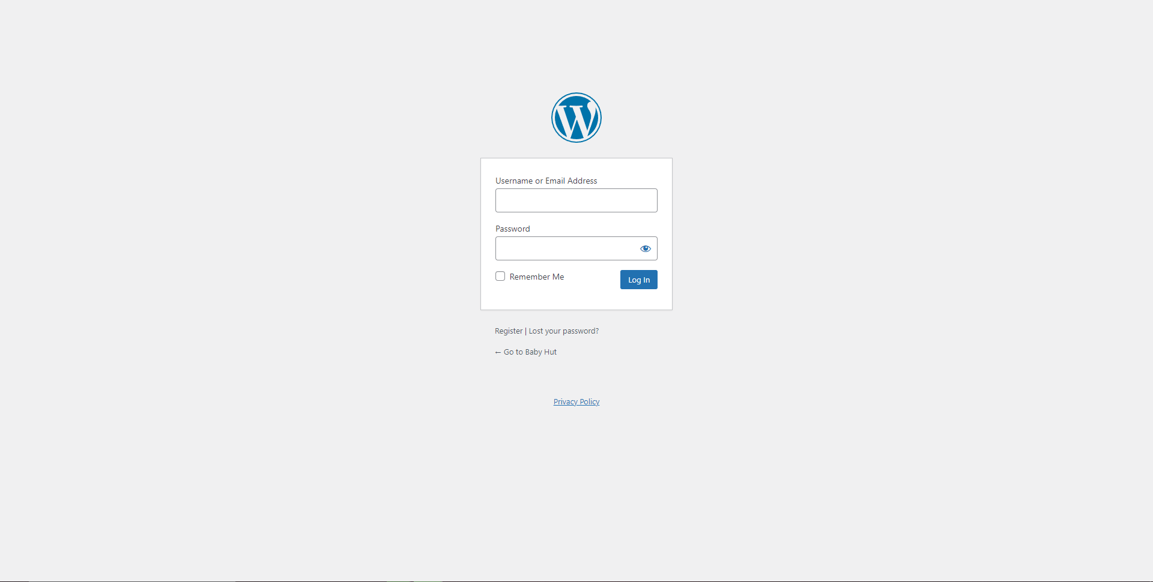

**Step 2:** Now you are in the **Dashboard** section. Follow the steps below to generate desired reports.

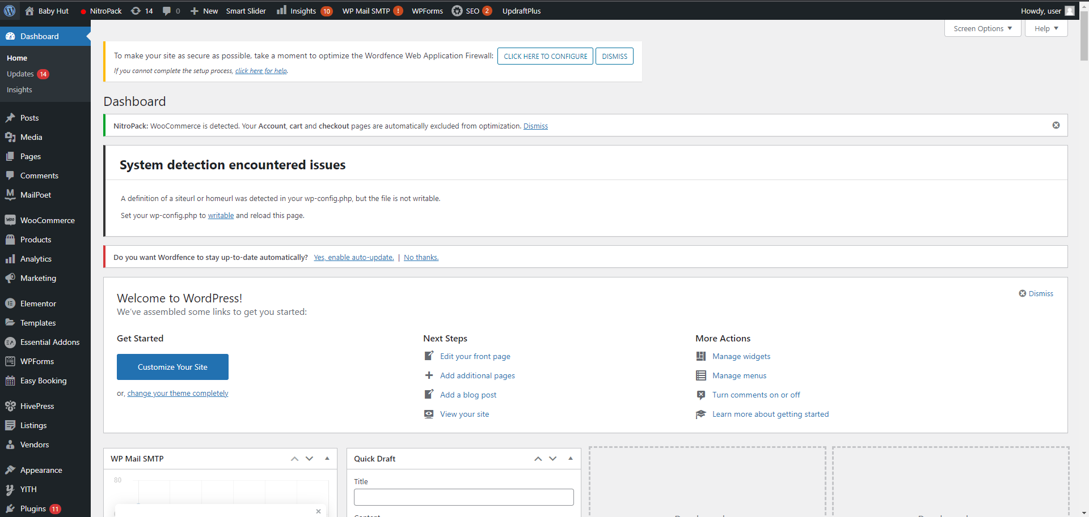

### 11.3.2 Rental reports

**Step 1:** On the left side, **Easy Booking,** hover on it, then click **Reports** from the box.

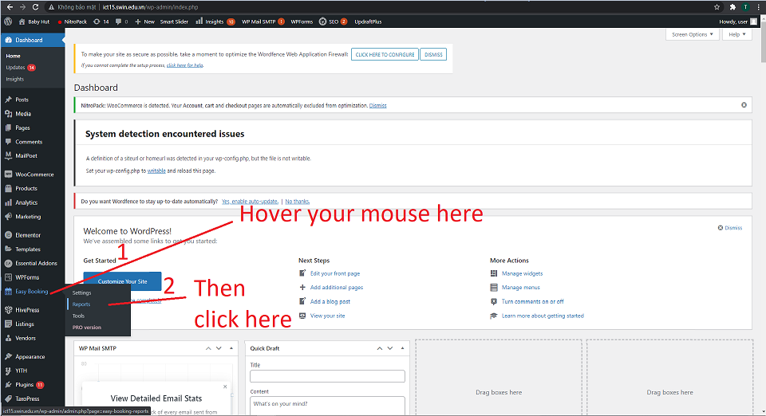

**Step 2:** A list of rental products will be presented

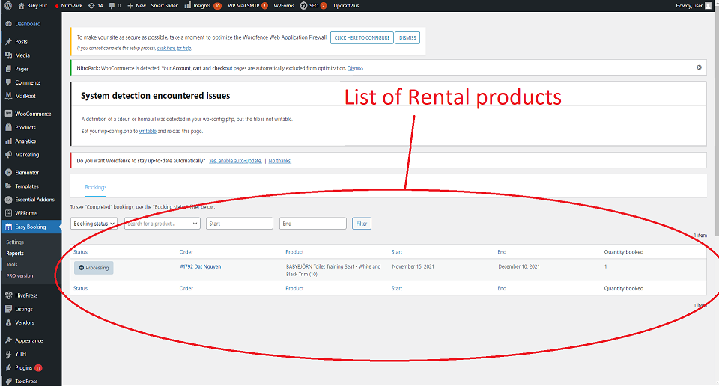

### 11.3.3 Member transaction history

**Step 1:** Find **Customers Order History** on the left side, hover on it, then click **User Order History.**

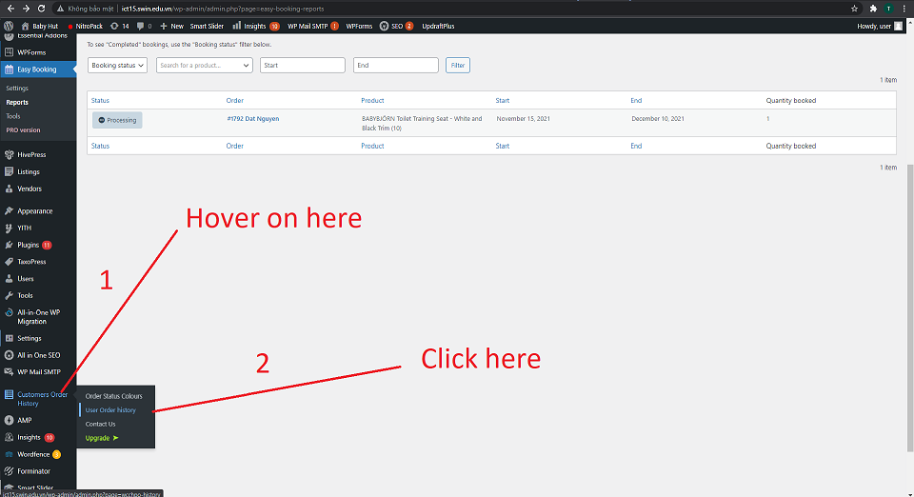

**Step 2:** Then, click on the **Customer** tab to get a list of customers. 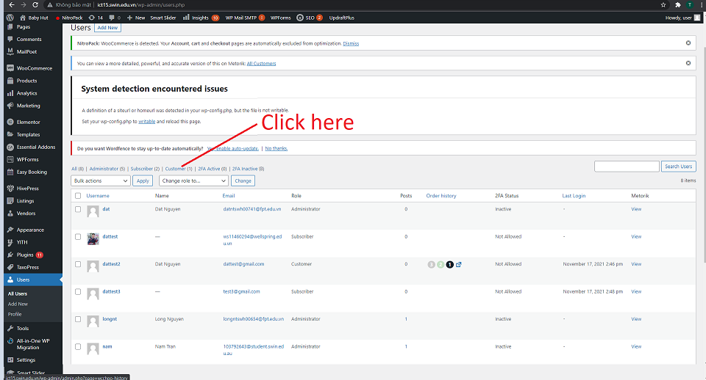

**Step 3:** Then, click on the icon under the **Order History** attribute. It will take you to the order history page of the customer.

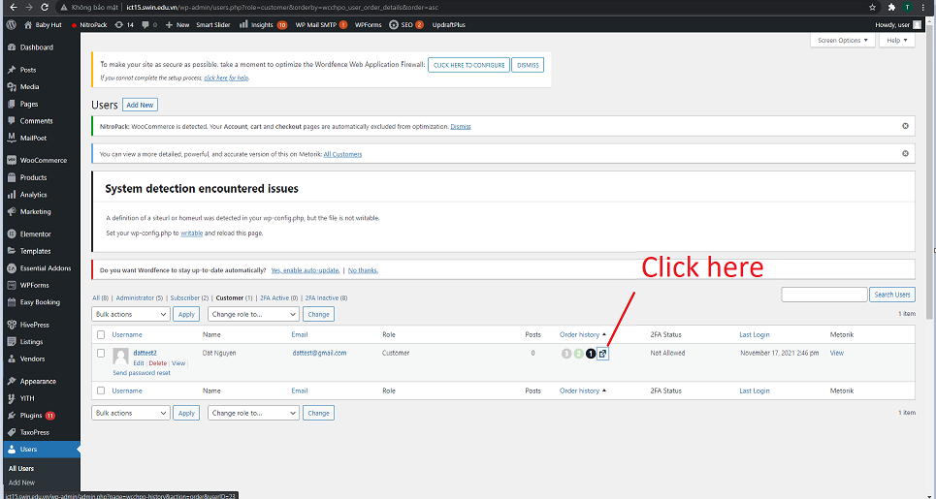

**Step 4:** You will be presented with the order history of the user. If you wish to download the excel version, click **Download order history.**

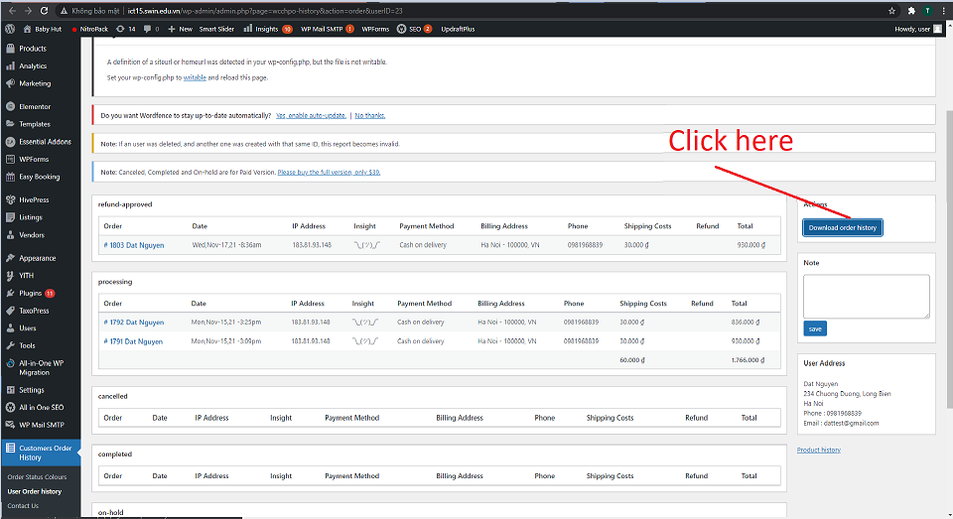

**Step 5:** Open the file, here is an example of the excel file. 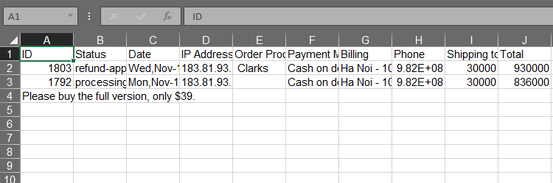

### 11.3.4 Rental Analysis Report

**Step 1:** On the left side, find and hover your mouse on **Analytics.** Then, click on **Categories**.

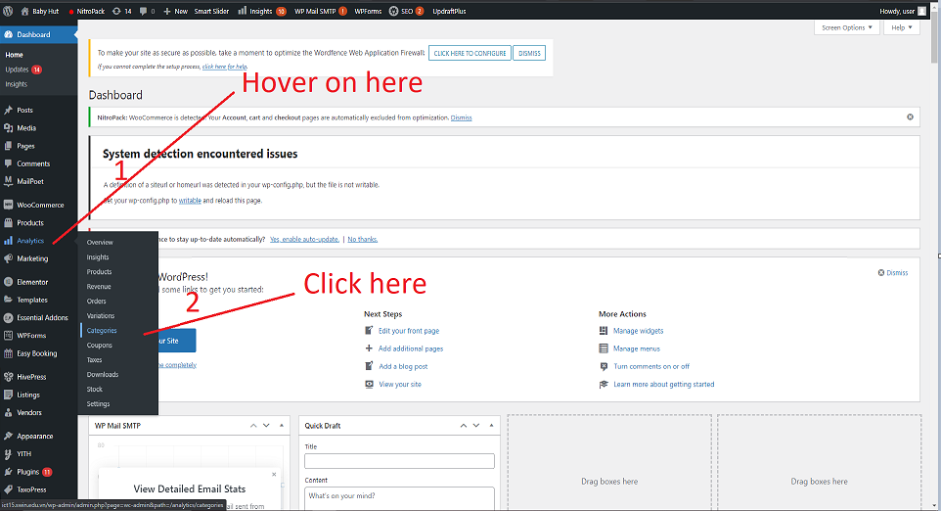

**Step 2:** You will be taken to the analysis page of product sales. Proceed to click on the **Rental Products.** 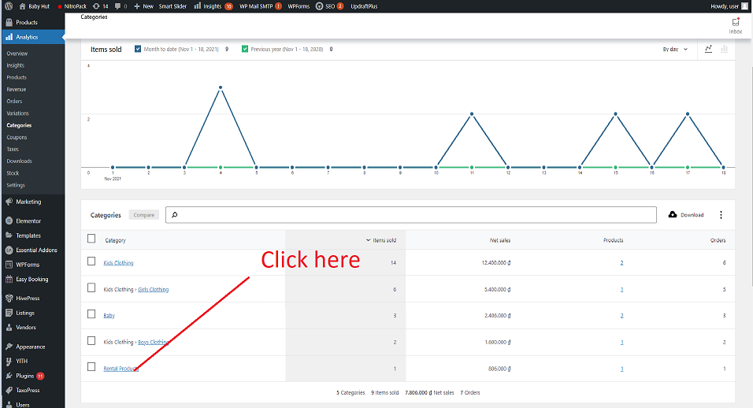

**Step 3:** You will be presented with a **Rental Analysis Report**. If you wish to download the file, click **Download.**

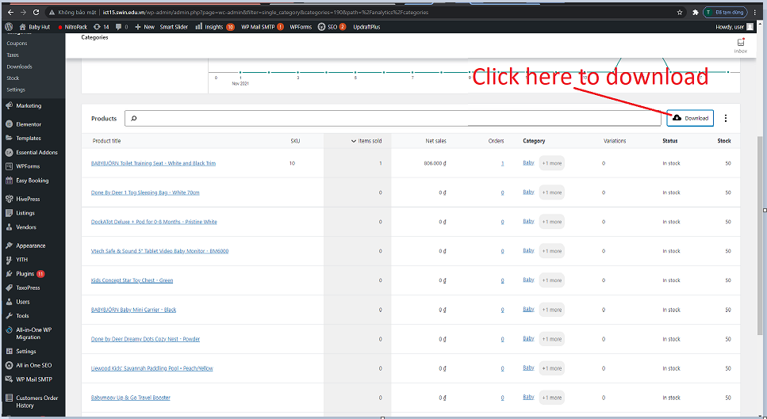

**Step 4:** Open the file, here is an example of the Excel file.

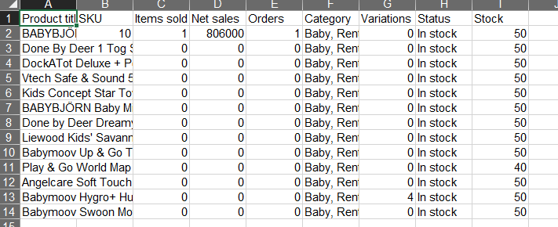

### 11.3.5 Catalogue of Baby Equipment

**Step 1:** On the left side, find and hover on **Analytics.** Then, click **Products.**

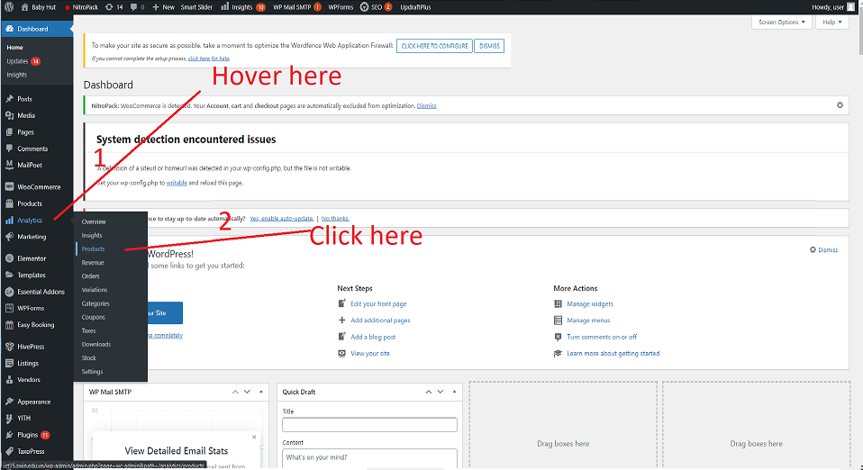

**Step 2:** You will be presented with a Catalogue of Baby equipment. If you wish to download the file, click **Download.**

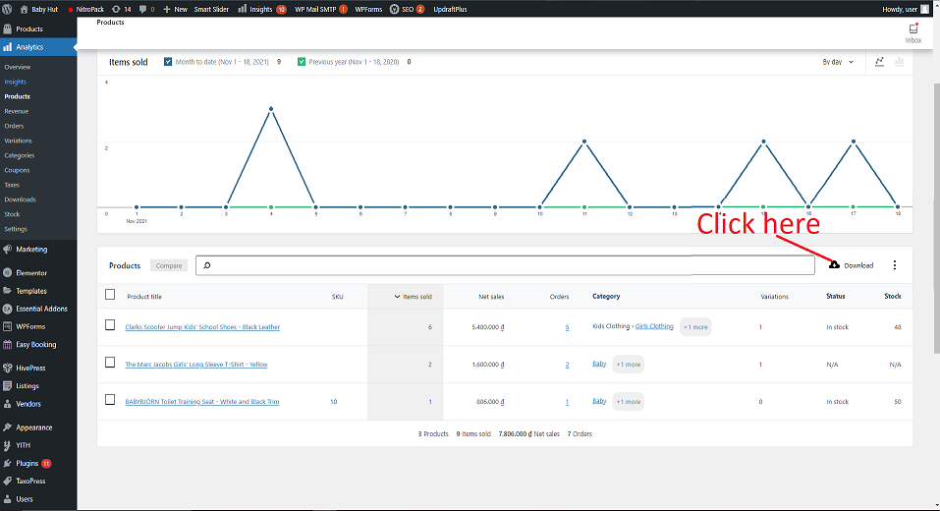

**Step 3:** Open the file, here is an example:

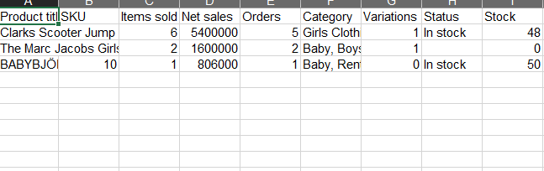

### 11.3.5 Out of stock report

**Step 1:** On the left side, find and hover on **WooCommerce.** Then, click **Reports.**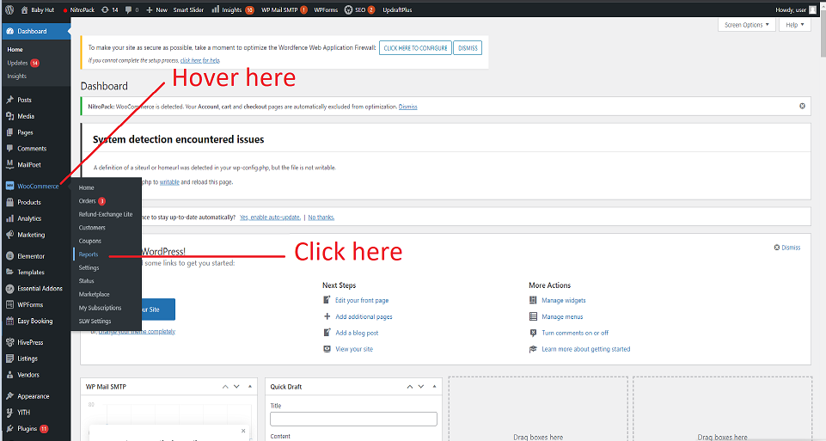

**Step 2:** Click the tab **Stock**

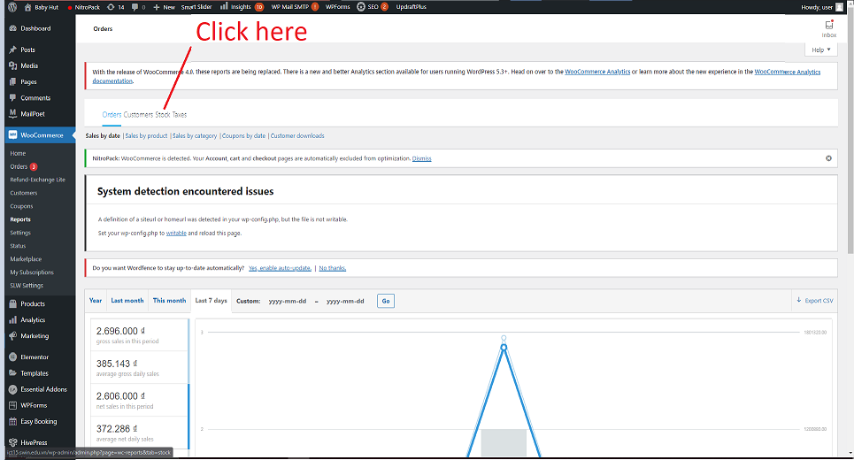

**Step 3:** Click on the tab of stock status you want to see. Click **Out of Stock** to get a list of equipment that ran out of stock. 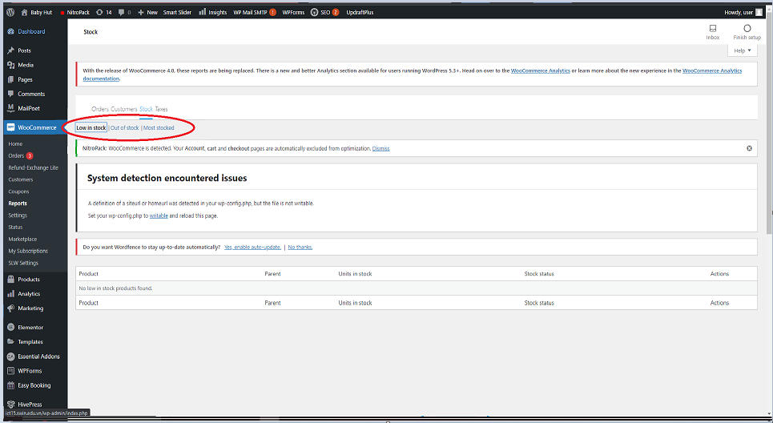

### 11.3.6 Return report

**Step 1:** On the left side, find and hover on **WooCommerce.** Then, click **Orders.**

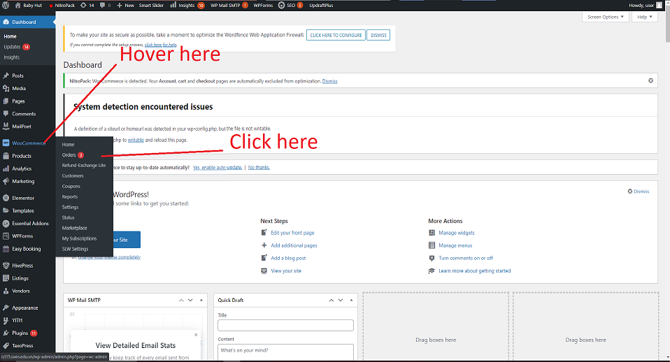

**Step 2:** Click the **Refund Approved** tab.

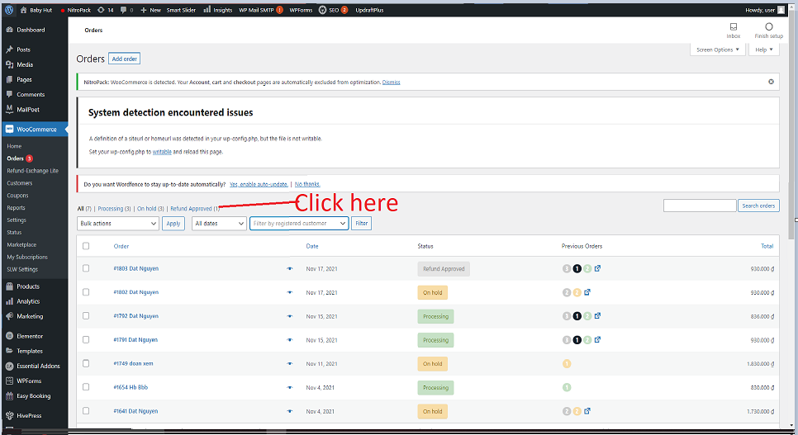

**Step 3:** You will be presented with a list of returned orders. 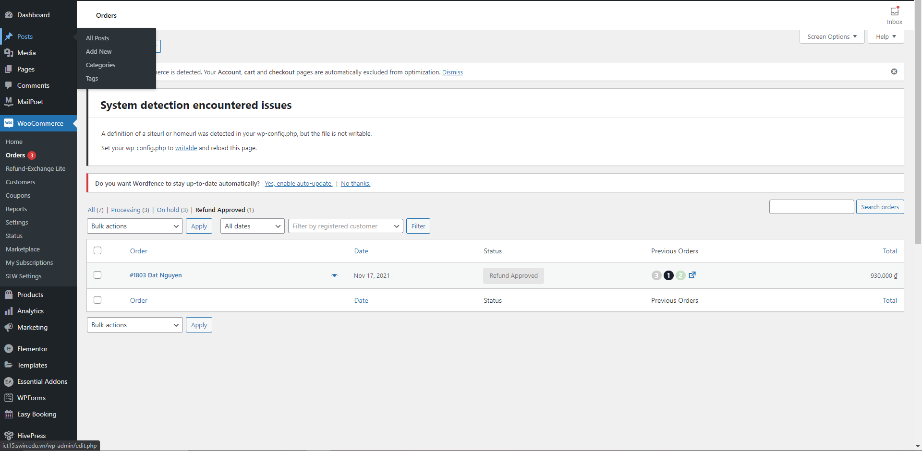

# 12. Optimizing page speed

Our site uses NitroPack's free plan for optimizing page speed. This section will guide you on how to get access to NitroPack settings.

## 12.1 Login

**Step 1:** Login <https://nitropack.io/user/login> with information provided in **section 2. Administrative information.** After filling in the information, click **Log me in.** 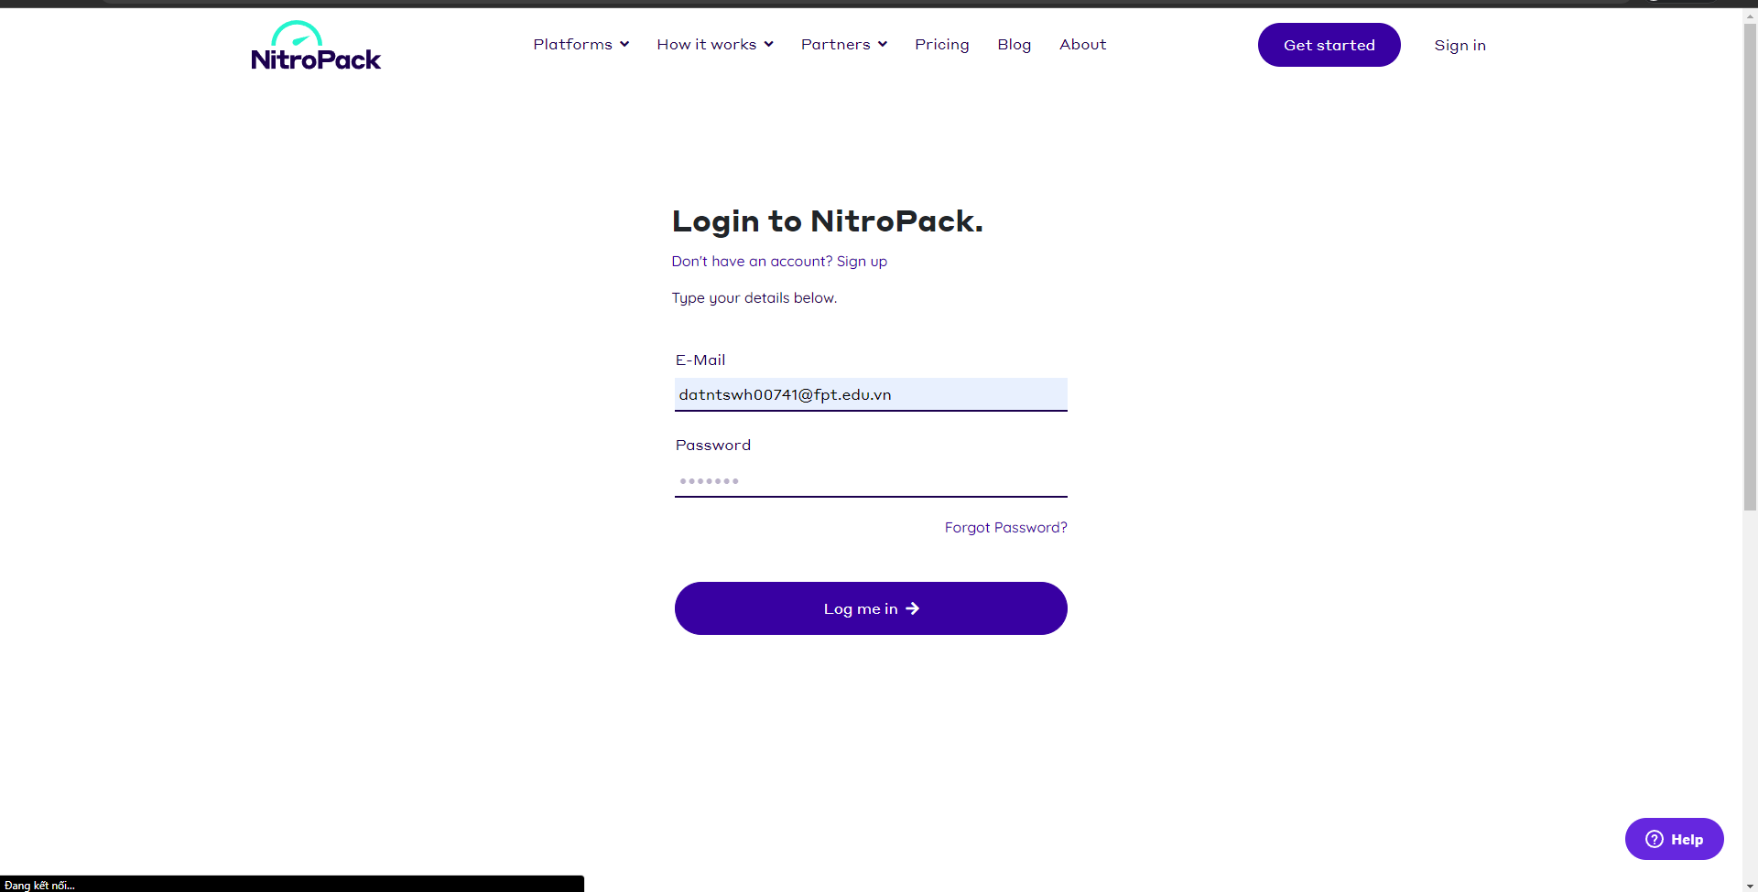

**Step 2:** Now you have access to the **Dashboard** of NitroPack. You can either upgrade to premium plan or change the settings of optimizing. 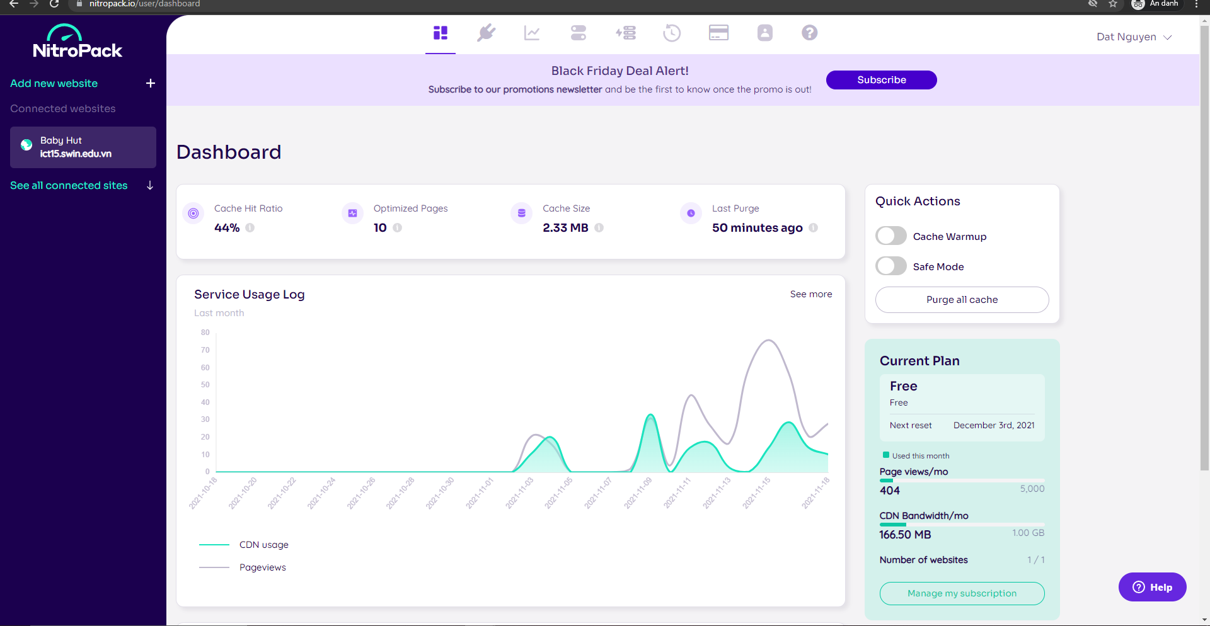

## 12.2 Changing optimization settings

NitroPack basically does everything automatically for you. But if you wish to dive into optimization settings, please refer to Appendix #4: Guide on configuring NitroPack for more information.

# 13. Technical summary

## 13.1 Domain information

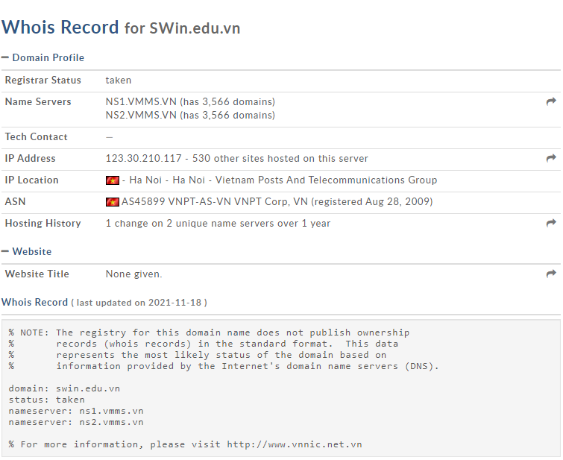

Information provided by https://whois.domaintools.com/

## 13.2 Hosting information

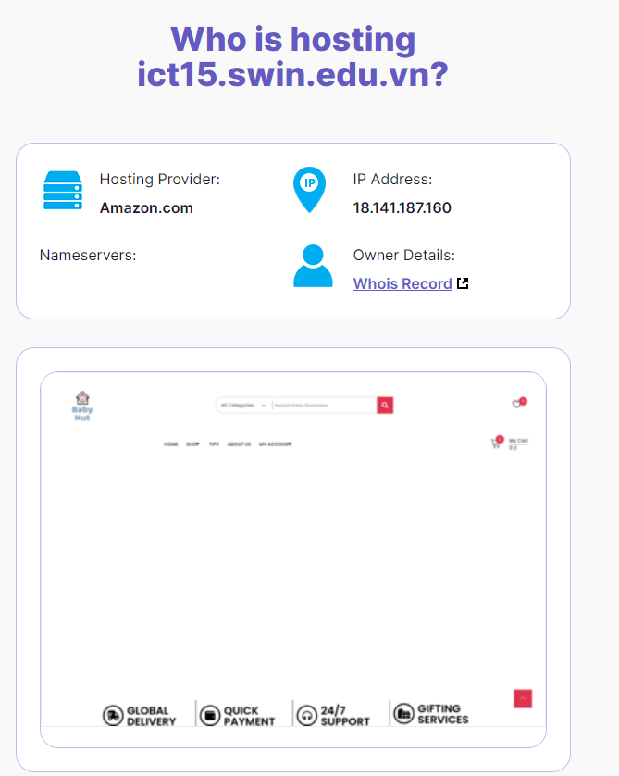

Information provided by https://digital.com/best-web-hosting/who-is/#search=ict15.swin.edu.vn

## 13.3 WordPress site

WordPress is a free, open-source platform for building websites. WordPress is a content management system (CMS) built in PHP that utilises a MySQL database on a more technical level. WordPress is the most user-friendly and powerful blogging and website-building platform available today.

## 13.4 Google account for Google Analytics

Information for the Google account for Google Analytics has been provided in **section 2. Administrative information.**

# Appendices

[Appendix #1: Guide on using Elementor](https://elementor.com/blog/base-theme-with-elementor/)

[Appendix #2: Guide on using Forminator](https://wpmudev.com/docs/wpmu-dev-plugins/forminator/)

[Appendix #3: Guide on using Tidio](https://www.tidio.com/blog/category/tips-tutorials/)

[Appendix #4: Guide on configuring NitroPack](https://support.nitropack.io/hc/en-us/articles/360062916353-Configuring-NitroPack)